

S.I.G.A.T.

I.S.U.

Rol | Apellido | Nombre | CI | E-mail | Cel/Tel
Cooridnadora | Galván Melgarejo | Camila Dahiana | 4740392-4 | caamila2332@gmail.com | 095888253 / 29026646
Sub-Coordinadora | Esquibel Rodriguéz | Giuliana María | 5021948-9 | giu.maa@hotmail.com | 094169682 / 26142595
Integrante 1 | Estévez Antúnez | Sebastían Julio | 4752098-6 | sestevez96@hotmail.com | 091073684 / 29013066

Fecha de culminación:
09/12/2016

CUARTA ENTREGA

ITI-CETP
3º BB

Pantalla del sistema:
Inicio del sistema:

Tambo:
Personal:

2.4. Animal
2.5. Alimento y venta
2.6. Control
2.7. Enlistar
2.8. Ordeñe

2.9. Lote
2.10. Clima

3. Código fuente
2.1. Inicio del sistema:
Public Class frmArranque

Private Sub Arranque_Load(sender As System.Object, e As System.EventArgs) Handles MyBase.Load
Lblpass.BackColor = Color.FromArgb(86, 116, 185)
lblUser.BackColor = Color.FromArgb(86, 116, 185)
cbxIdioma.BackColor = Color.FromArgb(86, 116, 185)
gbxLog.BackColor = Color.FromArgb(86, 116, 185)
End Sub

Private Sub pbxClose_Click(sender As System.Object, e As System.EventArgs) Handles pbxClose.Click
Me.Close()
End Sub

Private Sub pbxMini_Click(sender As System.Object, e As System.EventArgs) Handles pbxMini.Click
Me.WindowState = FormWindowState.Minimized
End Sub
Private Sub Pbxlogin_Click(ByVal sender As System.Object, ByVal e As System.EventArgs) Handles pbxgspot.Click
Try
CN.Open("MIODBC", tbxUser.Text, tbxPass.Text)
conexion = 1
Catch ex As Exception
MsgBox("Error :" + usuario + " / " + contrasenia)
Exit Sub
End Try
CN.CursorLocation = ADODB.CursorLocationEnum.adUseClient
If conexion = 1 Then
Me.Hide()
frmComienzo.Show()
End If
End Sub

Private Sub cbxIdioma_SelectedIndexChanged(sender As System.Object, e As System.EventArgs) Handles cbxIdioma.SelectedIndexChanged
If cbxIdioma.Text = "English" Then
idioma = 1
ElseIf cbxIdioma.Text = "Português" Then
idioma = 2
Else
idioma = 0
End If
Variables_asignacion()
Lblpass.Text = contrasenia
lblUser.Text = usuario
End Sub

End Class

Public Class frmComienzo

Private Sub frmISU_Load(sender As System.Object, e As System.EventArgs) Handles MyBase.Load
Permiso()
pnlMain.Dock = DockStyle.Fill
btnConfiguracion_ordenie.Text = configuracion
btnLote_animal.Text = lote
btnControl_animal.Text = control
cbxEnlistar.Items.Clear()
cbxEnlistar.Items.Add("Holando")
cbxEnlistar.Items.Add("Jersey")
cbxEnlistar.Items.Add("Primer show")
cbxEnlistar.Items.Add(vaca)
cbxEnlistar.Items.Add(vaquillona)
cbxEnlistar.Items.Add(seca)
cbxEnlistar.Items.Add(toro)
cbxEnlistar.Items.Add(novillo)
cbxEnlistar.Items.Add(anestro)
cbxEnlistar.Items.Add(ternero)
cbxEnlistar.Items.Add(ternera)
cbxEnlistar.Items.Add(rodeo)
cbxEnlistar.Items.Add(campo)
cbxEnlistar.Items.Add(tambo)
cbxEnlistar.Items.Add(servicio)
cbxEnlistar.Items.Add(preniada)
cbxEnlistar.Items.Add(lactancia)
cbxEnlistar.Items.Add(hembra)
cbxEnlistar.Items.Add(macho)
cbxEnlistar.Items.Add(antibiotico)
cbxEnlistar.Items.Add(ganado_act)
End Sub

Sub Permiso()
If CN.State <> 1 Then
MsgBox(conexion)
Else
sql = "select a.num_cargo from adquiere a, persona p where a.ci=p.ci and p.login ='" & frmArranque.tbxUser.Text & "'"
If Open_sql() Then
If rs.RecordCount() = 0 Then
MsgBox("Error : " + puesto)
Else
Select Case rs(0).Value
Case 0 'auxiliar
gbxAnimal.Enabled = True
cbxTambo.Enabled = False
btnEliminar_Animal.Enabled = False
gbxAlimento.Enabled = True
gbxOrdenie.Enabled = True
btnEnlistar.Enabled = True
cbxTambo.Enabled = False
pbxVenta.Enabled = False
Case 1 'adm_establecimiento
gbxTambo.Enabled = True
gbxPersonal.Enabled = True
gbxAnimal.Enabled = True
gbxAlimento.Enabled = True
gbxOrdenie.Enabled = True
btnEliminar_Personal.Enabled = False
btnIngresar_Personal.Enabled = False
btnModificar_Personal.Enabled = False
btnEnlistar.Enabled = True
cbxTambo.Enabled = False
btnLote_animal.Enabled = True
btnControl_animal.Enabled = True
btnConfiguracion_ordenie.Enabled = True
Case 2 'gerente
gbxTambo.Enabled = True
gbxPersonal.Enabled = True
btnEliminar_Personal.Enabled = False
btnIngresar_Personal.Enabled = False
btnModificar_Personal.Enabled = False
btnLote_animal.Enabled = True
btnControl_animal.Enabled = True
btnConfiguracion_ordenie.Enabled = True
gbxAnimal.Enabled = True
gbxAlimento.Enabled = True
gbxOrdenie.Enabled = True
btnEnlistar.Enabled = True
Case 3 'adm_sistema
gbxTambo.Enabled = True
gbxPersonal.Enabled = True
gbxAnimal.Enabled = True
gbxAlimento.Enabled = True
gbxOrdenie.Enabled = True
btnEnlistar.Enabled = True
btnLote_animal.Enabled = True
btnControl_animal.Enabled = True
btnConfiguracion_ordenie.Enabled = True
End Select
rs.Close()
sql = "select t.establecimiento from tambo t, persona p, tiene te where t.serie=te.serie and p.ci=te.ci and p.login='" & frmArranque.tbxUser.Text & "'"
If Open_sql() Then
If rs.RecordCount <> 0 Then
cbxTambo.Text = rs(0).Value
rs.Close()
sql = "Select t.serie from tambo t, tiene e, persona p where establecimiento='" & cbxTambo.Text & "' and e.serie=t.serie and p.ci=e.ci and p.login='" & frmArranque.tbxUser.Text & "'"
If Open_sql() Then
TSERIE = rs(0).Value
rs.Close()
sql = "select establecimiento from tambo"
If Open_sql() Then
cbxTambo.Items.Clear()
While Not rs.EOF()
cbxTambo.Items.Add(rs(0).Value)
rs.MoveNext()
End While
rs.Close()
End If
End If
End If
End If
End If
End If
End If
End Sub

Private Sub Cerrar()
If rs.State <> 0 Then
rs.Close()
End If
If CN.State <> 0 Then
CN.Close()
End If
End Sub

Private Sub pbxSalir_Click(sender As System.Object, e As System.EventArgs) Handles pbxSalir.Click
frmArranque.Show()
rs = Nothing
CN = Nothing
Cerrar()
Me.Close()
End Sub

Private Sub pbxClima_Click(sender As System.Object, e As System.EventArgs) Handles pbxClima.Click
frmClima.MdiParent = Me
frmClima.Show()
pnlMain.Hide()
End Sub

Private Sub btnIngresar_Animal_Click(sender As System.Object, e As System.EventArgs) Handles btnIngresar_Animal.Click
opcion = 0
frmAnimal.MdiParent = Me
frmAnimal.Show()
pnlMain.Hide()
End Sub

Private Sub btnEliminar_Animal_Click(ByVal sender As System.Object, ByVal e As System.EventArgs) Handles btnEliminar_Animal.Click
opcion = 3
frmAnimal.MdiParent = Me
frmAnimal.Show()
pnlMain.Hide()
End Sub

Private Sub btnConsultar_Animal_Click(ByVal sender As System.Object, ByVal e As System.EventArgs) Handles btnConsultar_Animal.Click
opcion = 2
frmAnimal.MdiParent = Me
frmAnimal.Show()
pnlMain.Hide()
End Sub

Private Sub btnModificar_Animal_Click(ByVal sender As System.Object, ByVal e As System.EventArgs) Handles btnModificar_Animal.Click
opcion = 1
frmAnimal.MdiParent = Me
frmAnimal.Show()
pnlMain.Hide()
End Sub

Private Sub btnIngresar_Tambo_Click(ByVal sender As System.Object, ByVal e As System.EventArgs) Handles btnIngresar_Tambo.Click
opcion = 0
frmTambo.MdiParent = Me
frmTambo.Show()
pnlMain.Hide()
End Sub

Private Sub btnEliminar_Tambo_Click(ByVal sender As System.Object, ByVal e As System.EventArgs) Handles btnEliminar_Tambo.Click
opcion = 3
frmTambo.MdiParent = Me
frmTambo.Show()
pnlMain.Hide()
End Sub

Private Sub btnConsultar_Tambo_Click(ByVal sender As System.Object, ByVal e As System.EventArgs) Handles btnConsultar_Tambo.Click
opcion = 2
frmTambo.MdiParent = Me
frmTambo.Show()
pnlMain.Hide()
End Sub

Private Sub btnModificar_Tambo_Click(ByVal sender As System.Object, ByVal e As System.EventArgs) Handles btnModificar_Tambo.Click
opcion = 1
frmTambo.MdiParent = Me
frmTambo.Show()
pnlMain.Hide()
End Sub

Private Sub btnIngresar_Ordenie_Click(ByVal sender As System.Object, ByVal e As System.EventArgs)
opcion = 0
frmOrdenie.MdiParent = Me
frmOrdenie.Show()
pnlMain.Hide()
End Sub

Private Sub btnEliminar_Ordenie_Click(ByVal sender As System.Object, ByVal e As System.EventArgs)
opcion = 3
frmOrdenie.MdiParent = Me
frmOrdenie.Show()
pnlMain.Hide()
End Sub

Private Sub btnConsultar_Ordenie_Click(ByVal sender As System.Object, ByVal e As System.EventArgs) Handles btnConsultar_Ordenie.Click
opcion = 2
frmOrdenie.MdiParent = Me
frmOrdenie.Show()
pnlMain.Hide()
End Sub

Private Sub btnModifcar_Ordenie_Click(ByVal sender As System.Object, ByVal e As System.EventArgs)
opcion = 1
frmOrdenie.MdiParent = Me
frmOrdenie.Show()
pnlMain.Hide()
End Sub

Private Sub btnOtorgar_Alimento_Click(ByVal sender As System.Object, ByVal e As System.EventArgs) Handles btnOtrogar_Alimento.Click
opcion = 3
frmAlimento.MdiParent = Me
frmAlimento.Show()
pnlMain.Hide()
End Sub

Private Sub btnAlmacenar_Alimento_Click(ByVal sender As System.Object, ByVal e As System.EventArgs) Handles btnAlmacenar_Alimento.Click
opcion = 1
frmAlimento.MdiParent = Me
frmAlimento.Show()
pnlMain.Hide()
End Sub

Private Sub btnIngresar_Alimento_Click(ByVal sender As System.Object, ByVal e As System.EventArgs) Handles btnIngresar_Alimento.Click
opcion = 0
frmAlimento.MdiParent = Me
frmAlimento.Show()
pnlMain.Hide()
End Sub

Private Sub btnIngresar_Personal_Click(ByVal sender As System.Object, ByVal e As System.EventArgs) Handles btnIngresar_Personal.Click
opcion = 0
frmPersonal.MdiParent = Me
frmPersonal.Show()
pnlMain.Hide()
End Sub

Private Sub btnEliminar_Personal_Click(ByVal sender As System.Object, ByVal e As System.EventArgs) Handles btnEliminar_Personal.Click
opcion = 3
frmPersonal.MdiParent = Me
frmPersonal.Show()
pnlMain.Hide()
End Sub

Private Sub btnConsultar_Personal_Click(ByVal sender As System.Object, ByVal e As System.EventArgs) Handles btnConsultar_Personal.Click
opcion = 2
frmPersonal.MdiParent = Me
frmPersonal.Show()
pnlMain.Hide()
End Sub

Private Sub btnModificar_Personal_Click(ByVal sender As System.Object, ByVal e As System.EventArgs) Handles btnModificar_Personal.Click
opcion = 1
frmPersonal.MdiParent = Me
frmPersonal.Show()
pnlMain.Hide()
End Sub

Private Sub pbxVenta_Click(ByVal sender As System.Object, ByVal e As System.EventArgs) Handles pbxVenta.Click
frmventa.MdiParent = Me
frmventa.Show()
pnlMain.Hide()
End Sub

Private Sub btnControl_animal_Click(sender As System.Object, e As System.EventArgs) Handles btnControl_animal.Click
frmControl.MdiParent = Me
frmControl.Show()
pnlMain.Hide()
End Sub

Private Sub btnConfiguracion_ordenie_Click(sender As System.Object, e As System.EventArgs) Handles btnConfiguracion_ordenie.Click
frmOrdenieConfig.MdiParent = Me
frmOrdenieConfig.Show()
pnlMain.Hide()
End Sub

Private Sub btnLote_Click(sender As System.Object, e As System.EventArgs) Handles btnLote_animal.Click
frmLote.MdiParent = Me
frmLote.Show()
pnlMain.Hide()
End Sub

Private Sub cbxTambo_SelectedIndexChanged(ByVal sender As System.Object, ByVal e As System.EventArgs) Handles cbxTambo.SelectedIndexChanged
sql = "Select t.serie from tambo t where establecimiento='" & cbxTambo.Text & "'"
If Open_sql() Then
TSERIE = rs(0).Value
rs.Close()
End If
End Sub

Private Sub pbxClose_Click(ByVal sender As System.Object, ByVal e As System.EventArgs) Handles pbxClose.Click
frmArranque.Close()
End Sub

Private Sub pbxMini_Click(ByVal sender As System.Object, ByVal e As System.EventArgs) Handles pbxMini.Click
Me.WindowState = FormWindowState.Minimized
End Sub

Private Sub btnEnlistar_Click(sender As System.Object, e As System.EventArgs) Handles btnEnlistar.Click
If cbxEnlistar.Text = "Holando" Then
sql = "select a.num, raza, nacimiento, lugar, progenitor_macho, progenitor_hembra from animal a, hay h where raza= 'Holando' and h.num_animal=a.num and h.serie_tambo=" & Val(TSERIE)
ElseIf cbxEnlistar.Text = "Jersey" Then
sql = "select a.num, raza, nacimiento, lugar, progenitor_macho, progenitor_hembra from animal a, hay h where raza= 'Jersey' and h.num_animal=a.num and h.serie_tambo=" & Val(TSERIE)
ElseIf cbxEnlistar.Text = "Primer show" Then
sql = "select a.num, raza, nacimiento, lugar, progenitor_macho, progenitor_hembra from animal a, hay h where raza= 'Primer show' and h.num_animal=a.num and h.serie_tambo=" & Val(TSERIE)
ElseIf cbxEnlistar.Text = vaca Then
sql = "select h.num_hembra, raza, nacimiento, lugar, progenitor_macho, progenitor_hembra from hembra h, estado e, pasa p, hay y, animal a where" + _
" h.num_hembra = p.num_hembra and e.nombre = '" & preniada & "' and e.num=h.num_hembra and a.num=h.num_hembra and h.num_hembra=y.num_animal and y.serie_tambo=" & Val(TSERIE)
ElseIf cbxEnlistar.Text = vaquillona Then
opcion = 10
ElseIf cbxEnlistar.Text = toro Then
sql = "select m.num_macho, raza, nacimiento, lugar, progenitor_macho, progenitor_hembra from macho m, animal a, hay h where castrado=0 and a.num=m.num_macho and h.num_animal=a.num and h.serie_tambo=" & Val(TSERIE)
ElseIf cbxEnlistar.Text = novillo Then
sql = "select m.num_macho, raza, nacimiento, lugar, progenitor_macho, progenitor_hembra from macho m, animal a, hay h where castrado=1 and a.num=m.num_macho and h.num_animal=a.num and h.serie_tambo=" & Val(TSERIE)
ElseIf cbxEnlistar.Text = anestro Then
sql = "select h.num_hembra, raza, nacimiento, lugar, progenitor_macho, progenitor_hembra from hembra h, estado e, pasa p, hay y, animal a where" + _
" h.num_hembra = p.num_hembra and e.nombre = '" & anestro & "' and p.num_estado=e.num and a.num=h.num_hembra and h.num_hembra=y.num_animal and y.serie_tambo=" & Val(TSERIE)
ElseIf cbxEnlistar.Text = ternero Then
sql = "select c.num_cria, raza, nacimiento, lugar, progenitor_macho, progenitor_hembra from animal a, cria c, hay y where c.num_cria=a.num and sexo='" & macho _
& "' and c.num_cria=y.num_animal and y.serie_tambo=" & Val(TSERIE)
ElseIf cbxEnlistar.Text = ternera Then
sql = "select c.num_cria, raza, nacimiento, lugar, progenitor_macho, progenitor_hembra from animal a, cria c, hay y where c.num_cria=a.num and sexo='" & hembra _
& "' and c.num_cria=y.num_animal and y.serie_tambo=" & Val(TSERIE)
ElseIf cbxEnlistar.Text = rodeo Then
sql = "select a.num, raza, nacimiento, lugar, progenitor_macho, progenitor_hembra from animal a, hay y where lugar = '" & rodeo & "' and a.num=y.num_animal and y.serie_tambo=" & Val(TSERIE)
ElseIf cbxEnlistar.Text = campo Then
sql = "select a.num, raza, nacimiento, lugar, progenitor_macho, progenitor_hembra from animal a, hay y where lugar = '" & campo & "' and a.num=y.num_animal and y.serie_tambo=" & Val(TSERIE)
ElseIf cbxEnlistar.Text = tambo Then
sql = "select a.num, raza, nacimiento, lugar, progenitor_macho, progenitor_hembra from animal a, hay y where lugar = '" & tambo & "' and a.num=y.num_animal and y.serie_tambo=" & Val(TSERIE)
ElseIf cbxEnlistar.Text = servicio Then
sql = "select h.num_hembra, raza, nacimiento, lugar, progenitor_macho, progenitor_hembra from hembra h, estado e, pasa p, animal a, hay y where" + _
" h.num_hembra = p.num_hembra and e.nombre = '" & servicio & "' and p.num_estado=e.num and a.num=h.num_hembra and h.num_hembra=y.num_animal and y.serie_tambo=" & Val(TSERIE)
ElseIf cbxEnlistar.Text = preniada Then
sql = "select h.num_hembra, raza, nacimiento, lugar, progenitor_macho, progenitor_hembra from hembra h, estado e, pasa p, hay y, animal a where" + _
" h.num_hembra = p.num_hembra and e.nombre = '" & preniada & "' and p.num_estado=e.num and a.num=h.num_hembra and h.num_hembra=y.num_animal and y.serie_tambo=" & Val(TSERIE)
ElseIf cbxEnlistar.Text = lactancia Then
sql = "select h.num_hembra, raza, nacimiento, lugar, progenitor_macho, progenitor_hembra from hembra h, estado e, pasa p, hay y, animal a where" + _
" h.num_hembra = p.num_hembra And e.nombre = '" & lactancia & "' and p.num_estado=e.num and a.num=h.num_hembra and h.num_hembra=y.num_animal and y.serie_tambo=" & Val(TSERIE)
ElseIf cbxEnlistar.Text = seca Then
sql = "select h.num_hembra, raza, nacimiento, lugar, progenitor_macho, progenitor_hembra from hembra h, estado e, pasa p, hay y, animal a where" + _
" h.num_hembra = p.num_hembra and e.nombre = '" & seca & "' and p.num_estado=e.num and a.num=h.num_hembra and h.num_hembra=y.num_animal and y.serie_tambo=" & Val(TSERIE)
ElseIf cbxEnlistar.Text = hembra Then
sql = "select h.num_hembra, raza, nacimiento, lugar, progenitor_macho, progenitor_hembra from hembra h, hay y, animal a where h.num_hembra = a.num and h.num_hembra=y.num_animal and y.serie_tambo=" & Val(TSERIE)
ElseIf cbxEnlistar.Text = macho Then
sql = "select m.num_macho, raza, nacimiento, lugar, progenitor_macho, progenitor_hembra from macho m, hay y, animal a where m.num_macho = a.num and y.num_animal=a.num and y.serie_tambo=" & Val(TSERIE)
ElseIf cbxEnlistar.Text = ganado_act Then
sql = "Select a.num, raza, nacimiento, lugar, progenitor_macho, progenitor_hembra from animal a, hay y where activo = 1 and a.num=y.num_animal and y.serie_tambo=" & Val(TSERIE)
ElseIf cbxEnlistar.Text = antibiotico Then
sql = "select h.num_hembra, raza, nacimiento, lugar, progenitor_macho, progenitor_hembra from hembra h, animal a, estado e, hay y where" + _
" h.num_hembra = a.num And e.nombre = '" & antibiotico & "' and a.num=h.num_hembra and h.num_hembra=y.num_animal and y.serie_tambo=" & Val(TSERIE)
End If
frmEnlistar.Show()
End Sub

Private Sub pnlMain_Paint(sender As System.Object, e As System.Windows.Forms.PaintEventArgs) Handles pnlMain.Paint

End Sub
End Class

2.2. Tambo:
Public Class frmTambo
Dim Modifi(3) As String
Private Sub Tambo_Load(ByVal sender As System.Object, ByVal e As System.EventArgs) Handles MyBase.Load
Me.Dock = DockStyle.Fill
Boton_idioma(btnOpcion)
Me.Text = tambo + ", " + btnOpcion.Text
lblganado_max.Text = ganado_max
lblHectareas.Text = hectareas
lblNombre.Text = nombre
lblSerie.Text = serie
btnBuscar.Text = buscar
gbxTanque.Text = tanque
lblNSerie.Text = numero + " " + serie
lblCapacidad.Text = capacidad
btnTanque_Agregar.Text = agregar
btnTanque_Quitar.Text = eliminar
tbxSerie.Text = TSERIE
tbxSerie.Enabled = False
Select Case opcion
Case 0 'ingresar
sql = "Select max(serie) from tambo"
If Open_sql() Then
tbxSerie.Text = Val(Val(rs(0).Value) + 1)
rs.Close()
End If

Case 1 'modificar
Consultar_Tambo()
Modifi(0) = tbxNombre.Text
Modifi(1) = tbxHectareas.Text
Modifi(2) = tbxGanado_max.Text
Case 2 'consultar
Consultar_Tambo()
Case 3 'eliminar
Consultar_Tambo()
btnBuscar.Enabled = False
tbxSerie.Enabled = True
btnBuscar.Enabled = True
gbxGeneral.Enabled = False
End Select
End Sub

Private Sub btnOpcion_Click(ByVal sender As System.Object, ByVal e As System.EventArgs) Handles btnOpcion.Click
Dim acum As Integer
Dim Modifi_now(3) As String
Dim i As Integer
Dim change As Boolean = False
acum = 0
acum = Validacion_numerica(tbxGanado_max.Text, acum)
acum = Validacion_numerica(tbxHectareas.Text, acum)
If acum = 0 Then
Select Case opcion
Case 0
sql = "insert into tambo(establecimiento, hectareas, ganado_max) values ('" & tbxNombre.Text & "', " & Val(tbxHectareas.Text) & ", " & Val(tbxGanado_max.Text) & ")"
Case 1
Modifi_now(0) = tbxNombre.Text
Modifi_now(1) = tbxHectareas.Text
Modifi_now(2) = tbxGanado_max.Text
i = 0
While i <= 3 And change = False
If Modifi(i) <> Modifi_now(i) Then
change = True
If change Then
sql = "update tambo set establecimiento='" & tbxNombre.Text & "', hectareas=" & Val(tbxHectareas.Text) & ", ganado_max=" & Val(tbxGanado_max.Text) & " where serie=" & Val(TSERIE)
i = 4
End If
Else
i = i + 1
End If
End While
Case 3
Dim res = MessageBox.Show(eliminar + "?", eliminar, MessageBoxButtons.YesNo, MessageBoxIcon.Information)
If res = Windows.Forms.DialogResult.Yes Then
sql = "delete from tambo where serie=" & Val(tbxSerie.Text)
End If

End Select
execute_sql()
Else
MsgBox("", MsgBoxStyle.OkOnly, "ERROR")
End If

End Sub

Private Sub btnBuscar_Click(ByVal sender As System.Object, ByVal e As System.EventArgs) Handles btnBuscar.Click
sql = "SELECT * from Tambo where serie=" & Val(tbxSerie.Text)
If Open_sql() Then
If rs.RecordCount <> 0 Then
tbxSerie.Enabled = False
btnBuscar.Enabled = False
gbxGeneral.Enabled = True
btnOpcion.Enabled = True
rs.Close()
Consultar_Tambo()
Else
rs.Close()
MsgBox("Error :" + serie + " " + tambo)
End If
End If

End Sub

Private Sub Consultar_Tambo()
sql = "Select establecimiento, hectareas, ganado_max from tambo where serie=" & Val(tbxSerie.Text)
If Open_sql() Then
tbxNombre.Text = rs(0).Value
tbxHectareas.Text = rs(1).Value
tbxGanado_max.Text = rs(2).Value
rs.Close()
End If

sql = "select t.num_serie, t.capacidad from tanque t, posee p, tambo ta where p.serie_tanque=t.num_serie and p.serie_tambo=ta.serie and ta.serie =" & Val(TSERIE)
If Open_sql() Then
If rs.RecordCount <> 0 Then
tbxNserie.Text = rs(0).Value
tbxCapacidad.Text = rs(1).Value
End If
rs.Close()
End If

End Sub

Private Sub btnTanque_Agregar_Click(ByVal sender As System.Object, ByVal e As System.EventArgs) Handles btnTanque_Agregar.Click
Dim acum As Integer
acum = 0
acum = Validacion_numerica(tbxCapacidad.Text, acum)
acum = Validacion_numerica(tbxNserie.Text, acum)
If acum = 0 Then
sql = "Select * from tanque where serie=" & Val(tbxNserie.Text)
If rs.RecordCount = 0 Then
rs.Close()
sql = "insert into tanque(num_serie, capacidad) values (" & Val(tbxNserie.Text) & ", " & Val(tbxCapacidad.Text) & ")"
execute_sql()
sql = "insert into posee(serie_tambo, serie_tanque) values (" & Val(tbxSerie.Text) & ", " & Val(tbxNserie.Text) & ")"
execute_sql()
End If
Else
MsgBox("Error :" + serie + " " + tanque)
End If
End Sub

Private Sub btnTanque_Quitar_Click(ByVal sender As System.Object, ByVal e As System.EventArgs) Handles btnTanque_Quitar.Click
Dim acum As Integer
acum = 0
acum = Validacion_numerica(tbxNserie.Text, acum)
If acum = 0 Then
sql = "Delete From posee Where serie_tanque = " & Val(tbxNserie.Text)
execute_sql()
sql = "Delete From tanque Where Num_serie = " & Val(tbxNserie.Text)
execute_sql()
End If
End Sub

Private Sub pbxMini_Click(ByVal sender As System.Object, ByVal e As System.EventArgs) Handles pbxMini.Click
Me.WindowState = FormWindowState.Minimized
frmComienzo.pnlMain.Show()
End Sub

Private Sub pbxClose_Click(ByVal sender As System.Object, ByVal e As System.EventArgs) Handles pbxClose.Click
frmComienzo.pnlMain.Show()
Me.Close()
End Sub
End Class

2.3. Personal:
Public Class frmPersonal
Dim Modifi(6) As String
Private Sub Personal_Load(sender As System.Object, e As System.EventArgs) Handles MyBase.Load
Me.Dock = DockStyle.Fill
lblCI.Text() = CI
lblPermiso.Text() = puesto
lblNacimiento.Text = nacimiento
lblNombre.Text = nombre
lblTelefono.Text = telefono

lblNacimiento.Text = nacimiento
lblSexo.Text = sexo
Boton_idioma(btnOpcion)
Me.Text = personal + ", " + btnOpcion.Text
btnBuscar.Text = buscar

cbxSexo.Items.Clear()
cbxSexo.Items.Add(hembra)
cbxSexo.Items.Add(macho)

cbxPuesto.Items.Clear()
cbxPuesto.Items.Add(auxiliar)
cbxPuesto.Items.Add(adm_establecimiento)
cbxPuesto.Items.Add(gerente)
cbxPuesto.Items.Add(adm_sistema)

cbxTelefono.Items.Clear()

sql = "Select p.ci, p.apellido, p.Nombre from Persona p, tiene t where t.ci=p.ci and t.serie=" & Val(TSERIE)
If Open_sql() Then
If rs.RecordCount <> 0 Then
lbxEnlistar.Items.Clear()
While Not rs.EOF()
lbxEnlistar.Items.Add(rs(0).Value)
lbxEnlistar.Items.Add(" " + rs(1).Value + " " + rs(2).Value)
rs.MoveNext()
End While
End If
rs.Close()
End If

End Sub

Private Sub btnBuscar_Click(sender As System.Object, e As System.EventArgs) Handles btnBuscar.Click
Dim acum As Integer
acum = 0
acum = Validacion_numerica(tbxCI.Text, acum)
acum = Validacion_largo(tbxCI, acum)
If acum = 0 Then
sql = "SELECT p.ci from Personal p, hay h where ci=" & Val(tbxCI.Text) & " and p.ci=h.ci and h.serie=" & Val(TSERIE)
If Open_sql() Then
If rs.RecordCount <> 0 Then
If opcion <> 0 Then
tbxCI.Enabled = False
btnBuscar.Enabled = False
btnOpcion.Enabled = True
gbxDatos.Enabled = True
rs.Close()
Select Case opcion
Case 1
Consultar_personal()
Modifi(0) = tbxNombre.Text
Modifi(1) = cbxSexo.Text
Modifi(2) = dtpNacimiento.Text
Modifi(3) = cbxPuesto.Text
Modifi(4) = tbxApellido.Text
Modifi(5) = tbxLogin.Text
Case 2
Consultar_personal()
Case 3
Consultar_personal()
End Select
End If
Else
If rs.RecordCount = 0 And opcion = 0 Then
tbxCI.Enabled = False
btnBuscar.Enabled = False
btnOpcion.Enabled = True
gbxDatos.Enabled = True
End If
End If
rs.Close()
End If
Else
MsgBox(CI, MsgBoxStyle.OkOnly, "ERROR")
End If
End Sub
Private Sub Consultar_personal()
sql = "Select nombre, sexo, nacimiento, login, apellido from persona where ci=" & Val(tbxCI.Text)
If Open_sql() Then
tbxNombre.Text = rs(0).Value
cbxSexo.Text = rs(1).Value
dtpNacimiento.Text = rs(2).Value
tbxLogin.Text = rs(3).Value
tbxApellido.Text = rs(4).Value
rs.Close()
End If

sql = "Select c.nombre from persona p, cargo c, adquiere a where a.ci=p.ci and a.num_cargo=c.num and p.ci=" & Val(tbxCI.Text)
If Open_sql() Then
cbxPuesto.Text = rs(0).Value
rs.Close()
End If

sql = "Select telefono from personatel where ci=" & Val(tbxCI.Text)
If Open_sql() Then
cbxTelefono.Items.Clear()
If rs.RecordCount <> 0 Then
cbxTelefono.Text = rs(0).Value
cbxTelefono.Items.Clear()
While Not rs.EOF()
cbxTelefono.Items.Add(rs(0).Value)
rs.MoveNext()
End While
End If
rs.Close()
End If

End Sub

Private Function Cargo_num(ByVal carg As String) As Integer
Dim CAR As Integer
If carg = auxiliar Then
CAR = 0
ElseIf carg = adm_establecimiento Then
CAR = 1
ElseIf carg = gerente Then
CAR = 2
ElseIf carg = adm_sistema Then
CAR = 3
Else
MsgBox(puesto)
Exit Function
End If
Return CAR
End Function

Private Sub btnOpcion_Click(ByVal sender As System.Object, ByVal e As System.EventArgs) Handles btnOpcion.Click
Dim Modifi_Now(6) As String
Dim CAR As Integer
Dim change As Boolean = False
Select Case opcion
Case 0
sql = "insert into persona(activo, ci, nombre, sexo, nacimiento, login) values ( 1," & Val(tbxCI.Text) & ", '" & tbxNombre.Text & "', '" & cbxSexo.Text & "', '" _
& dtpNacimiento.Text & "', '" & tbxLogin.Text & "')"
execute_sql()
sql = "insert into tiene(ci, serie) values (" & Val(tbxCI.Text) & ", " & Val(TSERIE) & ")"
execute_sql()
CAR = Cargo_num(cbxPuesto.Text)
sql = "insert into adquiere(ci, num_cargo) values (" & Val(tbxCI) & ", " & CAR & ")"
execute_sql()
Case 1

Modifi_Now(0) = tbxNombre.Text
Modifi_Now(1) = cbxSexo.Text
Modifi_Now(2) = dtpNacimiento.Text
Modifi_Now(3) = cbxPuesto.Text
Modifi_Now(4) = tbxApellido.Text
Modifi_Now(5) = tbxLogin.Text
Dim i As Integer = 0
While i <= 6
If Modifi(i) <> Modifi_Now(i) Then
change = True
If change Then
sql = "update persona set nombre='" & tbxNombre.Text & "', sexo='" & cbxSexo.Text & "', nacimiento='" & dtpNacimiento.Text & "' where ci=" & Val(tbxCI.Text)
execute_sql()
sql = "update adquiere set num_cargo=" & cbxPuesto.Text & " where ci=" & Val(tbxCI.Text)
i = 8
End If
Else
i = i + 1
End If
End While
Case 3
Dim res = MessageBox.Show(eliminar + "?", "Error!", MessageBoxButtons.YesNo, MessageBoxIcon.Information)
If res = Windows.Forms.DialogResult.Yes Then
sql = "update persona set activo=0 where ci=" & Val(tbxCI.Text)
execute_sql()
End If

End Select
End Sub

Private Sub btnadd_Click(ByVal sender As System.Object, ByVal e As System.EventArgs) Handles btnadd.Click
sql = "insert into personatel(ci, telefono) values (" & Val(tbxCI.Text) & ", '" & cbxTelefono.Text & "')"
execute_sql()
cbxTelefono.Items.Add(cbxTelefono.Text)
End Sub

Private Sub btnrem_Click(ByVal sender As System.Object, ByVal e As System.EventArgs) Handles btnrem.Click
sql = "delete from personatel where ci= " & Val(tbxCI.Text) & " and telefono=" & Val(cbxTelefono.Text)
execute_sql()
cbxTelefono.Items.Remove(cbxTelefono.Text)
Try
cbxTelefono.Text = cbxTelefono.Items.Item(0)
Catch ex As Exception

End Try
End Sub

Private Sub pbxClose_Click(ByVal sender As System.Object, ByVal e As System.EventArgs) Handles pbxClose.Click
frmComienzo.pnlMain.Show()
Me.Close()
End Sub

Private Sub pbxMini_Click(ByVal sender As System.Object, ByVal e As System.EventArgs) Handles pbxMini.Click
Me.WindowState = FormWindowState.Minimized
frmComienzo.pnlMain.Show()
End Sub

Private Sub lbxEnlistar_SelectedIndexChanged(ByVal sender As System.Object, ByVal e As System.EventArgs) Handles lbxEnlistar.SelectedIndexChanged
Dim selected As String
selected = lbxEnlistar.SelectedItem.ToString()
If IsNumeric(selected) And opcion <> 0 Then
tbxCI.Text = selected
Consultar_personal()
btnBuscar.Enabled = False
btnOpcion.Enabled = True
If opcion <> 0 Then
gbxDatos.Enabled = True
End If

End If
End Sub
End Class

2.4. Animal:
Public Class frmAnimal
Dim Modifi As String
Private Sub frmAnimal_Load(sender As System.Object, e As System.EventArgs) Handles MyBase.Load
Me.Dock = DockStyle.Fill
Boton_idioma(btnOpcion)
Me.Text = animal + ", " + btnOpcion.Text
btnBuscar.Text = buscar
btnBuscarH.Text = buscar
btnBuscarM.Text = buscar
lblDivision.Text = division
lblSexo.Text = sexo
lblRazaM.Text = raza
lblRazaH.Text = raza
lblRaza.Text = raza
lblNumM.Text = numero
lblNumH.Text = numero
lblNumero.Text = numero
lblNacimiento.Text = nacimiento
lblLugar.Text = lugar
cbxSexo.Items.Clear()
cbxSexo.Items.Add(macho)
cbxSexo.Items.Add(hembra)
cbxLugar.Items.Clear()
cbxLugar.Items.Add(tambo)
cbxLugar.Items.Add(campo)
cbxLugar.Items.Add(rodeo)
cbxLugar.Items.Add(ninguno)

sql = "Select a.num, a.raza from animal a, hay h, tambo t where a.num=h.num_animal and h.serie_tambo=t.serie and activo=1 and t.serie=" & Val(TSERIE)
If Open_sql() Then
If rs.RecordCount <> 0 Then
While Not rs.EOF()
lbxEnlistar.Items.Add(rs(0).Value)
lbxEnlistar.Items.Add(" " + rs(1).Value)
rs.MoveNext()
End While
End If
rs.Close()
End If
If opcion = 1 Then
cbxSexo.Enabled = False
End If

End Sub

Private Sub btnBuscar_Click(sender As System.Object, e As System.EventArgs) Handles btnBuscar.Click
Dim acum As Integer
acum = 0
acum = Validacion_numerica(tbxNum.Text(), acum)
acum = Validacion_largo(tbxNum, acum)
If acum = 0 Then
sql = "SELECT * from Animal where num=" & Val(tbxNum.Text)
If Open_sql() Then
rs.Close()
btnOpcion.Enabled = True
tbxNum.Enabled = False
gbxBasico.Enabled = True
Select Case opcion
Case 1
Consulta_Animal()
Modifi = cbxDivision.Text
Case 2
Consulta_Animal()
Case 3
Consulta_Animal()
End Select
Else
If opcion = 0 Then
btnOpcion.Enabled = True
tbxNum.Enabled = False
gbxBasico.Enabled = True
End If
End If
Else
MsgBox("Error 1:" + numero + " " + animal)
End If
End Sub

Private Sub cbxSexo_SelectedIndexChanged(sender As System.Object, e As System.EventArgs) Handles cbxSexo.SelectedIndexChanged
cbxDivision.Items.Clear()
If cbxSexo.Text() = hembra Then
cbxDivision.Items.Add(vaca)
cbxDivision.Items.Add(vaquillona)
cbxDivision.Items.Add(ternera)
ElseIf cbxSexo.Text() = macho Then
cbxDivision.Items.Add(toro)
cbxDivision.Items.Add(novillo)
cbxDivision.Items.Add(ternero)
End If
End Sub

Private Sub btnBuscarM_Click(sender As System.Object, e As System.EventArgs) Handles btnBuscarM.Click
Dim acum As Integer
acum = 0
acum = Validacion_numerica(tbxNumM.Text(), acum)
acum = Validacion_largo(tbxNumM, acum)
If acum = 0 Then
sql = "Select m.num_macho from macho m, tambo t, hay h where m.num_macho=" & Val(tbxNum.Text) & " and t.serie=h.serie_tambo and m.num_macho=h.num_animal and t.serie= " & Val(TSERIE)
If Open_sql() Then
If rs.RecordCount <> 0 Then
rs.Close()
sql = "SELECT raza from Animal where num=" & Val(tbxNumM.Text)
If Open_sql() Then
cbxRazaH.Text = rs.value(0)
End If
Else
MsgBox("Error :" + numero + " " + animal)
End If
rs.Close()
End If

Else
MsgBox("Error :" + numero + " " + animal, MsgBoxStyle.OkOnly, "ERROR")
End If
End Sub

Private Sub btnBuscarH_Click(sender As System.Object, e As System.EventArgs) Handles btnBuscarH.Click
Dim acum As Integer
acum = 0
acum = Validacion_numerica(tbxNum.Text(), acum)
acum = Validacion_largo(tbxNum, acum)
If acum = 0 Then

sql = "Select he.num_hembra from hembra he, tambo t, hay h where h.num_animal=" & Val(tbxNum.Text) & " and t.serie=h.serie_tambo and he.num_hembra=h.num_animal and t.serie= " & Val(TSERIE)
If Open_sql() Then
If rs.RecordCount <> 0 Then
rs.Close()
sql = "SELECT raza from Animal a, tambo t, hay h where num=" & Val(tbxNumM.Text)
If Open_sql() Then
cbxRazaH.Text = rs.value(0)
End If

Else
MsgBox("Error :" + numero + " " + animal, MsgBoxStyle.OkOnly, "ERROR")
End If
rs.Close()
End If

Else
MsgBox("Error :" + numero + " " + animal, MsgBoxStyle.OkOnly, "ERROR")

End If
End Sub

Private Sub btnOpcion_Click(sender As System.Object, e As System.EventArgs) Handles btnOpcion.Click
Dim Modifi_Now As String
Dim acum As Integer
acum = 0
Select Case opcion
Case 0 'ingresar
Dim res = MessageBox.Show(ingresar + ", " + tbxNum.Text + ": " + cbxSexo.Text + "?", eliminar, MessageBoxButtons.YesNo, MessageBoxIcon.Information)
If res = Windows.Forms.DialogResult.Yes Then
sql = "INSERT into Animal(num, nacimiento, lugar, raza, activo) values (" & Val(tbxNum.Text) & ",'" & dtpNacimiento.Text & _
"', '" & cbxLugar.Text & "', '" & cbxRaza.Text & "', 1)"
execute_sql()
acum = Validacion_numerica(tbxNumM.Text(), acum)
acum = Validacion_largo(tbxNumM, acum)
acum = Validacion_numerica(tbxNumH.Text(), acum)
acum = Validacion_largo(tbxNumH, acum)
If acum = 0 Then
sql = "Select m.num_macho from macho m, tambo t, hay h where h.num_animal=" & Val(tbxNum.Text) & " and t.serie=h.serie_tambo and m.num_macho=h.num_animal and t.serie= " & Val(TSERIE)
If Open_sql() Then
rs.Close()
sql = "update animal set progenitor_macho=" & Val(tbxNumH.Text)
execute_sql()
sql = "Select m.num_hembra from hembra m, tambo t, hay h where h.num_animal=" & Val(tbxNum.Text) & " and t.serie=h.serie_tambo and m.num=h.num_animal and t.serie= " & Val(TSERIE)
Open_sql()
If rs.RecordCount <> 0 Then
sql = "update animal set progenitor_hembra=" & Val(tbxNumH.Text)
execute_sql()
Else
MsgBox("Error:" + numero + " progenitor " + hembra)
End If
End If
Else
MsgBox("Error:" + numero + " progenitor")
End If

If cbxDivision.Text = ternera Or cbxDivision.Text = ternero Then
sql = "INSERT into cria(num_cria, sexo) values (" & Val(tbxNum.Text) & ", '" & cbxSexo.Text & "')"
Else
If cbxSexo.Text = macho Then
If cbxDivision.Text = novillo Then
sql = "INSERT into Macho(num_macho, castrado) values (" & Val(tbxNum.Text) & ", 1)"
ElseIf cbxDivision.Text = toro Then
sql = "INSERT into Macho(num_macho, castrado) values (" & Val(tbxNum.Text) & ", 0)"
End If
Else
sql = "INSERT into Hembra(num_hembra) values (" & Val(tbxNum.Text) & ")"
End If
End If
execute_sql()
sql = "insert into hay(num_animal, serie_tambo) values (" & Val(tbxNum.Text) & ", " & Val(TSERIE) & ")"
execute_sql()
End If

Case 1 'modificar
Modifi_Now = cbxDivision.Text
If Modifi_Now <> Modifi Then
If cbxDivision.Text = novillo Then
sql = "update macho set castrado=1 where num_macho=" & Val(tbxNum.Text)
ElseIf cbxDivision.Text = toro Then
sql = "update macho set castrado=0 where num_macho=" & Val(tbxNum.Text)
ElseIf cbxDivision.Text = vaca Then
sql = "insert into pasa(num_hembra, fecha_inicio, fecha_fin, num_estado) values (" & Val(tbxNum.Text) & ", '" & Today & "','" & Today & "', 1)"
ElseIf cbxDivision.Text = vaquillona Then
sql = "insert into hembra(num_hembra) values (" & tbxNum.Text & ")"
ElseIf cbxDivision.Text = ternero Or cbxDivision.Text = ternera Then
sql = "insert into cria(num_cria, sexo) values (" & Val(tbxNum.Text) & ", '" & cbxSexo.Text & "')"
End If
execute_sql()
End If
sql = "update animal set progenitor_macho='" & Val(tbxNumM.Text) & "', progenitor_hembra='" & Val(tbxNumH.Text) & "', nacimiento='" & dtpNacimiento.Text & "', lugar='" & cbxLugar.Text & "', raza='" & cbxRaza.Text & "' where num=" & Val(tbxNum.Text)
execute_sql()
Case 3 'eliminar
Dim res = MessageBox.Show(eliminar + "?", eliminar, MessageBoxButtons.YesNo, MessageBoxIcon.Information)
If res = Windows.Forms.DialogResult.Yes Then
sql = "update animal set activo=0 where num=" & Val(tbxNum.Text)
execute_sql()
End If

End Select

End Sub

Private Sub Consulta_Animal()
sql = "Select raza, lugar, nacimiento, progenitor_macho, progenitor_hembra from animal where num=" & Val(tbxNum.Text)
If Open_sql() Then
cbxRaza.Text = rs(0).Value
cbxLugar.Text = rs(1).Value
dtpNacimiento.Text = rs(2).Value
Try
tbxNumM.Text = rs(3).Value
Catch ex As Exception
End Try
Try
tbxNumH.Text = rs(4).Value
Catch ex As Exception
End Try
rs.Close()

End If
sql = "Select num_cria from cria where num_cria=" & Val(tbxNum.Text)
If Open_sql() Then
rs.Close()
sql = "Select sexo from cria where num_cria=" & Val(tbxNum.Text)
If Open_sql() Then
If rs(0).Value = hembra Then
cbxDivision.Text = ternera
cbxSexo.Text = hembra
ElseIf rs(0).Value = macho Then
cbxDivision.Text = ternero
cbxSexo.Text = macho
End If
rs.Close()
End If
Else
sql = "Select num_hembra from hembra where num_hembra=" & Val(tbxNum.Text)
If Open_sql() Then
rs.Close()
cbxSexo.Text = hembra
sql = "Select nombre from estado E, pasa P where P.num_hembra=" & Val(tbxNum.Text) & "and nombre = '" & preniada & "'"
If Open_sql() Then
cbxDivision.Text = vaca
rs.Close()
Else
cbxDivision.Text = vaquillona
End If
Else
sql = "Select num_macho from macho where num_macho=" & Val(tbxNum.Text)
If Open_sql() Then
rs.Close()
cbxSexo.Text = macho
sql = "Select num_macho from macho where num_macho=" & Val(tbxNum.Text) & "and castrado = 1"
If Open_sql() Then
cbxDivision.Text = novillo
rs.Close()
Else
cbxDivision.Text = toro
End If

End If
End If
End If
End Sub

Private Sub pbxMini_Click(sender As System.Object, e As System.EventArgs) Handles pbxMini.Click
Me.WindowState = FormWindowState.Minimized
frmComienzo.pnlMain.Show()
End Sub

Private Sub pbxClose_Click(sender As System.Object, e As System.EventArgs) Handles pbxClose.Click
frmComienzo.pnlMain.Show()
Me.Close()
End Sub

Private Sub lbxEnlistar_SelectedIndexChanged(ByVal sender As System.Object, ByVal e As System.EventArgs) Handles lbxEnlistar.SelectedIndexChanged
Dim selected As String
selected = lbxEnlistar.SelectedItem.ToString()
If IsNumeric(selected) And opcion <> 0 Then
tbxNum.Text = selected
Consulta_Animal()
btnBuscar.Enabled = False
btnOpcion.Enabled = True
If opcion = 1 Then
Modifi = cbxDivision.Text
End If
If opcion <> 0 Then
gbxBasico.Enabled = True
End If
End If
End Sub
End Class

2.5. Alimento y venta:
Public Class frmAlimento

Private Sub frmAlimento_Load(sender As System.Object, e As System.EventArgs) Handles MyBase.Load
Me.Dock = DockStyle.Fill
dtpHora.CustomFormat = "HH:mm"
Select Case opcion
Case 1
Me.Text = alimento + ", " + almacenar
dtpHora.Hide()
lblHora.Hide()
Case 3
Me.Text = alimento + ", " + otorgar
gbxLote.Show()
Case 0
Me.Text = alimento + ", " + ingresar
dtpFecha.Hide()
dtpHora.Hide()
lblFecha.Hide()
lblHora.Hide()
tbxCantidad.Enabled = False
gbxLote.Enabled = False
End Select

gbxDatos.Text = tipo + "/" + alimento
lblTipo.Text = tipo
cbxTipo.Items.Clear()
If opcion = 1 Then
gbxLote.Enabled = False
sql = "select tipo from alimento"
Else
sql = "select a.tipo from alimento a, proporciona p, tambo t where a.num=p.num and p.serie=t.serie and t.serie=" & Val(TSERIE)
End If

If Open_sql() Then
If rs.RecordCount <> 0 Then
cbxTipo.Items.Clear()
While Not rs.EOF()
cbxTipo.Items.Add(rs(0).Value)
rs.MoveNext()
End While
End If
rs.Close()
End If
sql = "select f.num_lote from forma f, hay h, tambo t where f.num_hembra=h.num_animal and h.serie_tambo=t.serie and t.serie =" & Val(TSERIE)
If Open_sql() Then
If rs.RecordCount <> 0 Then
lbxEnlistarlote.Items.Clear()
While Not rs.EOF()
lbxEnlistarlote.Items.Add(rs(0).Value)
rs.MoveNext()
End While
End If
rs.Close()
End If

btnGuardar.Text = guardar
lblFecha.Text = fecha
lblHora.Text = hora
lblCantidad.Text = cantidad
End Sub

Private Sub btnGuardar_Click(sender As System.Object, e As System.EventArgs) Handles btnGuardar.Click
Dim acum As Integer
Dim num As String
Dim acum2 As Integer
acum = 0
If tbxCantidad.Enabled Then
acum = Validacion_numerica(tbxCantidad.Text, acum)
End If
If opcion = 0 Then
sql = "INSERT into alimento(tipo) values ('" & cbxTipo.Text & "')"
execute_sql()
Else
sql = "Select num from alimento where tipo='" & cbxTipo.Text & "'"
If Open_sql() And acum = 0 Then
num = rs(0).Value

rs.Close()
Select Case opcion
Case 1
sql = "Insert into proporciona (serie,num, cant, fecha) values (" & Val(TSERIE) & ", " & Val(num) & ", '" & tbxCantidad.Text & _
"', '" & dtpFecha.Text & "')"
Case 3

acum2 = 0
acum2 = Validacion_numerica(tbxNumLote.Text, acum2)
If acum2 = 0 Then
sql = "Select num_hembra from forma where num_lote=" & tbxNumLote.Text
If Open_sql() Then
While Not rs.EOF()
sql = "Insert into se_da(num_alimento, num_animal, cant, fecha, hora) values (" & num & ", " & rs(0).Value & ", " & Val(tbxCantidad.Text) & _
", '" & dtpFecha.Text & "', '" & dtpHora.Text & "')"
execute_sql()
rs.MoveNext()
End While
rs.Close()
End If
Else
MsgBox("Error : " + num_lote, MsgBoxStyle.OkOnly, "ERROR")
End If
End Select
execute_sql()

End If
End If

End Sub

Private Sub pbxClose_Click(ByVal sender As System.Object, ByVal e As System.EventArgs) Handles pbxClose.Click
frmComienzo.pnlMain.Show()
Me.Close()
End Sub

Private Sub pbxMini_Click(ByVal sender As System.Object, ByVal e As System.EventArgs) Handles pbxMini.Click
Me.WindowState = FormWindowState.Minimized
frmComienzo.pnlMain.Show()
End Sub

Private Sub lbxEnlistarlote_SelectedIndexChanged(ByVal sender As System.Object, ByVal e As System.EventArgs) Handles lbxEnlistarlote.SelectedIndexChanged
Dim selected As String
selected = lbxEnlistarlote.SelectedItem.ToString()
tbxNumLote.Text = selected
End Sub
End Class

Public Class frmVenta

Private Sub Venta_Load(sender As System.Object, e As System.EventArgs) Handles MyBase.Load
Me.Dock = DockStyle.Fill
Me.Text = venta
gbxDatos.Text = ""
lblTipo.Text = litros
btnGuardar.Text = guardar
lblFecha.Text = fecha
lblCantidad.Text = cantidad
End Sub

Private Sub btnGuardar_Click(sender As System.Object, e As System.EventArgs) Handles btnGuardar.Click
Dim acum, max As Integer
acum = 0
acum = Validacion_numerica(tbxCantidad.Text, acum)
If acum = 0 Then
sql = "insert into cooperativa(serie) values(0)"
execute_sql()
sql = "select max(serie) from cooperativa"
If Open_sql() Then
max = Val(rs(0).Value)
rs.Close()
sql = "Select num_serie from tanque"
If Open_sql() Then
sql = "INSERT into retira(num_tanque, serie_coop, fecha_retira, cant) values (" & Val(rs(0).Value) & ", " & max & ", '" & dtpFecha.Text & "', " & tbxCantidad.Text & ")"
execute_sql()
rs.Close()
End If
End If

Else
MsgBox(cantidad, MsgBoxStyle.OkOnly, "ERROR")
End If
End Sub

Private Sub pbxClose_Click(sender As System.Object, e As System.EventArgs) Handles pbxClose.Click
frmComienzo.pnlMain.Show()
Me.Close()
End Sub

Private Sub pbxMini_Click(sender As System.Object, e As System.EventArgs) Handles pbxMini.Click
Me.WindowState = FormWindowState.Minimized
frmComienzo.pnlMain.Show()
End Sub
End Class

2.6. Control:
Public Class frmControl
Private Sub frmControl_Load(ByVal sender As System.Object, ByVal e As System.EventArgs) Handles MyBase.Load
Me.Dock = DockStyle.Fill
Me.Text = animal + ", " + control
lblFecha.Text = fecha
lblNumero.Text = numero
lblPeso.Text = peso
chbVacuna.Text = vacuna
btnBuscar.Text = buscar
btnGuardar.Text = guardar
btnEtapa_add.Text = agregar
lblRecriavuelta.Text = fecha_vuelta
lblRecriaIda.Text = fecha_ida
lblFechaI.Text = fechaI
lblFechaF.Text = fechaF
lblRecria.Text = campo
lblEtapa.Text = etapa
cbxEtapa.Items.Clear()
cbxEtapa.Items.Add(ninguno)
cbxEtapa.Items.Add(servicio)
cbxEtapa.Items.Add(anestro)

sql = "Select a.num, a.raza from animal a, hay h, tambo t where a.num=h.num_animal and h.serie_tambo=t.serie and t.serie=" & Val(TSERIE)
If Open_sql() Then
lbxEnlistar.Items.Clear()
While Not rs.EOF()
lbxEnlistar.Items.Add(rs(0).Value)
lbxEnlistar.Items.Add(" " + rs(1).Value)
rs.MoveNext()
End While
rs.Close()
End If

sql = "Select num_camp_re from campo_de_recria"
If Open_sql() Then
cbxRecria.Items.Clear()
While Not rs.EOF()
cbxRecria.Items.Add(rs(0).Value)
rs.MoveNext()
End While
rs.Close()
End If

sql = "Select vacuna from controla"
If Open_sql() Then
cbxVacuna.Items.Clear()
While Not rs.EOF()
cbxVacuna.Items.Add(rs(0).Value)
rs.MoveNext()
End While
rs.Close()
End If

End Sub

Private Sub btnBuscar_Click(sender As System.Object, e As System.EventArgs) Handles btnBuscar.Click
Dim acum As Integer
acum = 0
acum = Validacion_numerica(tbxNum.Text(), acum)
acum = Validacion_largo(tbxNum, acum)
If acum = 0 Then
sql = "Select he.num from hembra he, tambo t, hay h where hnum=" & Val(tbxNum.Text) & " and t.serie=h.serie and he.num=h.num and t.serie= " & Val(TSERIE)
If rs.RecordCount <> 0 Then
rs.Close()
tbxNum.Enabled = False
gbxGeneral.Enabled = True
End If
Else
MsgBox("Error :" + numero + " " + animal, MsgBoxStyle.OkOnly, "ERROR")
End If
End Sub

Private Sub chbVacuna_CheckedChanged(sender As System.Object, e As System.EventArgs) Handles chbVacuna.CheckedChanged
cbxVacuna.Enabled = True
End Sub

Private Sub btnGuardar_Click(sender As System.Object, e As System.EventArgs) Handles btnGuardar.Click
sql = "select ci from persona where login='" & frmArranque.tbxUser.Text & "'"
If Open_sql() Then
If rs.RecordCount <> 0 Then
sql = "Insert into controla(vacuna, peso, fecha, ci_personal, num_animal) values('" & cbxVacuna.Text & "', " & Val(tbxPeso.Text) & ", '" & dtpNacimiento.Text & "', " & Val(rs(0).Value) & ", " & Val(tbxNum.Text) & ")"
execute_sql()
End If
rs.Close()
End If

End Sub

Private Sub pbxMini_Click(sender As System.Object, e As System.EventArgs) Handles pbxMini.Click
Me.WindowState = FormWindowState.Minimized
frmComienzo.pnlMain.Show()
End Sub

Private Sub pbxClose_Click(sender As System.Object, e As System.EventArgs) Handles pbxClose.Click
frmComienzo.pnlMain.Show()
Me.Close()
End Sub

Private Sub btnEtapa_add_Click(sender As System.Object, e As System.EventArgs) Handles btnEtapa_add.Click
sql = "select num from estado where nombre='" & cbxEtapa.Text & "'"
If Open_sql() Then
sql = "insert into estado(nombre) values ('" & cbxEtapa.Text & "')"
execute_sql()
rs.Close()
sql = "select num from estado where nombre='" & cbxEtapa.Text & "'"
If Open_sql() Then
sql = "insert into pasa(num_hembra, num_estado, fecha_inicio, fecha_fin) values (" & Val(tbxNum.Text) & ", " & Val(rs(0).Value) & ", " & dtpInicio.Text & ", " & dtpFin.Text & ")"
execute_sql()
rs.Close()
End If

End If
End Sub

Private Sub cbxEtapa_SelectedIndexChanged(sender As System.Object, e As System.EventArgs) Handles cbxEtapa.SelectedIndexChanged
lblFechaF.Enabled = True
lblFechaI.Enabled = True
dtpFin.Enabled = True
dtpInicio.Enabled = True
btnEtapa_add.Enabled = True
End Sub

Private Sub lbxEnlistar_SelectedIndexChanged(sender As System.Object, e As System.EventArgs) Handles lbxEnlistar.SelectedIndexChanged
Dim selected As String
selected = lbxEnlistar.SelectedItem.ToString()
If IsNumeric(selected) Then
tbxNum.Text = selected
btnBuscar.Enabled = False
gbxCria.Enabled = True
gbxEtapa.Enabled = True
gbxGeneral.Enabled = True
cbxRecria.Enabled = True
btnRecria.Enabled = True
btnRecria_Add.Enabled = True
End If
End Sub

Private Sub btnCampo_Click(sender As System.Object, e As System.EventArgs) Handles btnRecria_Add.Click
sql = "select * from campo_de_recria where num_camp_re=" & Val(cbxRecria.Text)
If Open_sql() Then
If rs.RecordCount <> 0 Then
rs.Close()
sql = "select * from va where num_cria=" & Val(tbxNum.Text)
If Open_sql() Then
If rs.RecordCount = 0 Then
sql = "insert into va(num_cria, fecha, num_camp_re) values (" & Val(tbxNum.Text) & ", " & dtpInicio.Text & ", " & cbxRecria.Text & ")"
Else
sql = "update va set fecha=" & dtpInicio.Text & " where cria=" & Val(cbxRecria.Text)
End If
rs.Close()
End If
execute_sql()
sql = "select * from retorna where num_animal=" & Val(cbxRecria.Text)
If Open_sql() Then
If rs.RecordCount = 0 Then
rs.Close()
sql = "select sexo from cria where num_cria=" & Val(tbxNum.Text)
If Open_sql() Then
If rs.RecordCount <> 0 Then
sql = "insert into retorna(num_animal, fecha_vuelta, num_camp_re) values (" & Val(tbxNum.Text) & ", " & dtpFin.Text & ", " & cbxRecria.Text & ")"
Else
sql = "insert into vuelve(num_hembra, fecha_vuelta, num_camp_re) values (" & Val(tbxNum.Text) & ", " & dtpFin.Text & ", " & cbxRecria.Text & ")"
End If
execute_sql()
rs.Close()
End If
Else
rs.Close()
sql = "select * from vuelve where num_hembra=" & Val(tbxNum.Text)
If Open_sql() Then
If rs.RecordCount <> 0 Then
sql = "update vuelve set fecha_vuelta=" & dtpFin.Text & " where num_hembra=" & Val(cbxRecria.Text)
Else
sql = "insert into vuelve(num_hmbra, fecha_vuelta, num_camp_re) values (" & Val(tbxNum.Text) & ", " & dtpFin.Text & ", " & cbxRecria.Text & ")"
End If
execute_sql()
rs.Close()
End If
End If
End If
Else
MsgBox("Error: " + numero + " " + campo)
End If
End If
End Sub

Private Sub btnRecria_Click(sender As System.Object, e As System.EventArgs) Handles btnRecria.Click
sql = "select * from campo_de_recria where num_camp_re=" & Val(cbxRecria.Text)
If Open_sql() Then
If rs.RecordCount = 0 Then
sql = "insert into campo_de_recria(num_camp_re) values (" & Val(cbxRecria.Text) & ")"
execute_sql()
Else
MsgBox("Error: " + numero + " " + campo)
End If
rs.Close()
End If
End Sub
End Class

2.7. Enlistar:
Public Class frmEnlistar
Private Sub frmEnlistar_Load(ByVal sender As System.Object, ByVal e As System.EventArgs) Handles MyBase.Load
lbxEnlistar.Items.Clear()
Me.Text = animal + ", " + enlistar
If Open_sql() Then
lbxEnlistar.Items.Clear()
While Not rs.EOF()
lbxEnlistar.Items.Add(rs(0).Value)
rs.MoveNext()
End While
rs.Close()
End If
End Sub

Private Sub pbxClose_Click(sender As System.Object, e As System.EventArgs) Handles pbxClose.Click
frmComienzo.pnlMain.Show()
Me.Close()
End Sub

Private Sub pbxMini_Click(sender As System.Object, e As System.EventArgs) Handles pbxMini.Click
Me.WindowState = FormWindowState.Minimized
frmComienzo.pnlMain.Show()
End Sub
End Class

2.8. Ordeñe:
Public Class frmOrdenie
Private Sub frmordenie_Load(sender As System.Object, e As System.EventArgs) Handles MyBase.Load
Me.Dock = DockStyle.Fill
dtphora.CustomFormat = "HH:mm"
lblTurno.Text = turno
lblLitros.Text = litros
lblGrasa.Text = grasa
lblProteina.Text = proteina
lblUrea.Text = urea
lblRecuentobac.Text = rec_bacteriano
lblRecuentoCel.Text = rec_celulas
lblNumLote.Text = num_lote
lblFecha.Text = fecha
chbConsumoe.Text = consumoe
chbConsumoi.Text = consumoi

sql = "select t.num_serie, t.capacidad from tanque t, posee p, tambo ta where p.serie_tanque=t.num_serie and p.serie_tambo=ta.serie and ta.serie =" & Val(TSERIE)
If Open_sql() Then
If rs.RecordCount <> 0 Then
lbxEnlistarTanque.Items.Clear()
While Not rs.EOF()
lbxEnlistarTanque.Items.Add(rs(0).Value)
Try
lbxEnlistarTanque.Items.Add(" " + rs(1).Value)
Catch
End Try
rs.MoveNext()
End While
End If
rs.Close()
End If
sql = "select f.num_lote from forma f, hay h, tambo t where f.num_hembra=h.num_animal and h.serie_tambo=t.serie and t.serie =" & Val(TSERIE)
If Open_sql() Then
If rs.RecordCount <> 0 Then
lbxEnlistarlote.Items.Clear()
While Not rs.EOF()
lbxEnlistarlote.Items.Add(rs(0).Value)
rs.MoveNext()
End While
End If
rs.Close()
End If
End Sub

Private Sub btnAgregar_Click(sender As System.Object, e As System.EventArgs) Handles btnAgregar.Click
frmLote.Show()
End Sub

Private Sub btnConsultar_Click(sender As System.Object, e As System.EventArgs)
frmLote.Show()
End Sub

Private Sub btnOrdeñado_Click(sender As System.Object, e As System.EventArgs) Handles btnOrdeñado.Click
Dim acum As Integer
acum = Validacion_numerica(tbxLitros.Text, acum)
acum = Validacion_numerica(tbxGrasa.Text, acum)
acum = Validacion_numerica(tbxProteina.Text, acum)
acum = Validacion_numerica(tbxUrea.Text, acum)
acum = Validacion_numerica(tbxRecuentobac.Text, acum)
acum = Validacion_numerica(tbxRecuentocel.Text, acum)
acum = Validacion_numerica(tbxConsumoi.Text, acum)
acum = Validacion_numerica(tbxConsumoi.Text, acum)
acum = Validacion_numerica(tbxNumLote.Text, acum)
If Val(tbxLitros.Text) <> (Val(tbxConsumoe.Text) + Val(tbxConsumoi.Text)) Then
acum = acum + 1
End If
If acum = 0 Then
sql = "insert into produce(fecha, hora, num_lote, tipo, cantidad, rec_bact, grasa, proteina, cel_som,urea) values ('" & _
dtpFecha.Text & "', '" & dtphora.Text & "', " & Val(tbxNumLote.Text) & ", 'Comerciable', " & Val(tbxConsumoe.Text) & _
", " & Val(tbxRecuentobac.Text) & ", " & Val(tbxGrasa.Text) & ", " & Val(tbxProteina.Text) & ", " & Val(tbxRecuentocel.Text) & _
", " & Val(tbxUrea.Text) & " )"
execute_sql()
sql = "insert into produce(fecha, hora, num_lote, tipo, cantidad, rec_bact, grasa, proteina, cel_som,urea) values ('" & _
dtpFecha.Text & "', '" & dtphora.Text & "', " & Val(tbxNumLote.Text) & ", 'NoComerciable', " & Val(tbxConsumoi.Text) & _
", " & Val(tbxRecuentobac.Text) & ", " & Val(tbxGrasa.Text) & ", " & Val(tbxProteina.Text) & ", " & Val(tbxRecuentocel.Text) & _
", " & Val(tbxUrea.Text) & " )"
execute_sql()
sql = "insert into almacena(tipo, fecha, num_serie, cant,hora) values ('Comerciable', '" & dtpFecha.Text & "', " & Val(tbxNserie.Text) & _
", " & Val(tbxConsumoe.Text) & ", '" & dtphora.Text & "')"
execute_sql()
End If

End Sub

Private Sub btnTanque_Consultar_Click(sender As System.Object, e As System.EventArgs)
sql = "select t.serie, t.capacidad from tanque t, almacena a, produce p, hay h, tambo o where t.serie=a.serie and a.tipo=p.tipo and p.num=h.num and o.serie =" & Val(TSERIE)
frmEnlistar.Show()
End Sub

Private Sub pbxMini_Click(ByVal sender As System.Object, ByVal e As System.EventArgs) Handles pbxMini.Click
Me.WindowState = FormWindowState.Minimized
frmComienzo.pnlMain.Show()
End Sub

Private Sub pbxClose_Click(ByVal sender As System.Object, ByVal e As System.EventArgs) Handles pbxClose.Click
frmComienzo.pnlMain.Show()
Me.Close()
End Sub

Private Sub cbxCantidad_SelectedIndexChanged(ByVal sender As System.Object, ByVal e As System.EventArgs) Handles cbxCantidad.SelectedIndexChanged
gbxLeche.Enabled = True
gbxFH.Enabled = True
End Sub

Private Sub lbxEnlistarlote_SelectedIndexChanged(sender As System.Object, e As System.EventArgs) Handles lbxEnlistarlote.SelectedIndexChanged
Dim selected As String
selected = lbxEnlistarlote.SelectedItem.ToString()
tbxNumLote.Text = selected
End Sub

Private Sub lbxEnlistarTanque_SelectedIndexChanged(sender As System.Object, e As System.EventArgs) Handles lbxEnlistarTanque.SelectedIndexChanged
Dim selected As String
selected = lbxEnlistarTanque.SelectedItem.ToString()
tbxNserie.Text = selected
sql = "select capacidad from tanque where num_serie=" & Val(selected)
If Open_sql() Then
tbxCapacidad.Text = rs(0).Value
End If
End Sub
End Class

Public Class frmOrdenieConfig
Private Sub frmordenieConfig_Load(sender As System.Object, e As System.EventArgs) Handles MyBase.Load
Me.Dock = DockStyle.Fill
dtpFinalp.CustomFormat = "HH:mm:ss"
dtpFinals.CustomFormat = "HH:mm:ss"
dtpFinalt.CustomFormat = "HH:mm:ss"
dtpIniciop.CustomFormat = "HH:mm:ss"
dtpInicios.CustomFormat = "HH:mm:ss"
dtpIniciot.CustomFormat = "HH:mm:ss"
Me.Text = ordenie + ", " + configuracion
lblFinalp.Text = hora + " " + fin
lblIniciop.Text = hora + " " + inicio
lblFinals.Text = hora + " " + fin
lblInicios.Text = hora + " " + inicio
lblFinalt.Text = hora + " " + fin
lblIniciot.Text = hora + " " + inicio
gbxPrimer.Text = primer
gbxSegundo.Text = segundo
gbxTercer.Text = tercero
lblOrdeniecant.Text = cantidad + "/" + ordenie
btnGuardar.Text = guardar
sql = "select max(num_ordenie) from parametros where serie_tambo=" & Val(TSERIE)
If Open_sql() Then
If Val(rs(0).Value) = 3 Then
rs.Close()
cbxCantidad.Text = 3
Horas(dtpIniciop, dtpFinalp, 1)
Horas(dtpInicios, dtpFinals, 2)
Horas(dtpIniciot, dtpFinalt, 3)
ElseIf Val(rs(0).Value) = 2 Then
rs.Close()
cbxCantidad.Text = 2
Horas(dtpIniciop, dtpFinalp, 1)
Horas(dtpInicios, dtpFinals, 2)
ElseIf Val(rs(0).Value) = 1 Then
cbxCantidad.Text = 1
Horas(dtpIniciop, dtpFinalp, 1)
Else
opcion = 10
End If
cbxCantidad_SelectedIndexChanged(sender, e)
End If

End Sub

Public Sub Horas(ByVal dtpI As DateTimePicker, ByVal dtpF As DateTimePicker, ByVal num As Integer)
sql = "select hora_inicio, hora_fin from parametros where serie_tambo=" & Val(TSERIE) & " and num_ordenie=" & num
If Open_sql() Then
dtpI.Text = rs(0).Value
dtpF.Text = rs(1).Value
rs.Close()
End If

End Sub

Private Sub cbxCantidad_SelectedIndexChanged(sender As System.Object, e As System.EventArgs) Handles cbxCantidad.SelectedIndexChanged
If cbxCantidad.Text = "1" Then
gbxPrimer.Enabled = True
gbxSegundo.Enabled = False
gbxTercer.Enabled = False
ElseIf cbxCantidad.Text = "2" Then
gbxPrimer.Enabled = True
gbxSegundo.Enabled = True
gbxTercer.Enabled = False
ElseIf cbxCantidad.Text = "3" Then
gbxPrimer.Enabled = True
gbxSegundo.Enabled = True
gbxTercer.Enabled = True
End If
If Val(cbxCantidad.Text) < 3 Then
sql = "Select * from parametros where num_ordenie=3 and serie_tambo=" & Val(TSERIE)
If Open_sql() Then
If rs.RecordCount <> 0 Then
sql = "delete from parametros where num_ordenie=3 and serie_tambo=" & Val(TSERIE)
End If
rs.Close()
End If

End If
If Val(cbxCantidad.Text) < 2 Then
sql = "Select * from parametros where num_ordenie=2 and serie_tambo=" & Val(TSERIE)
If Open_sql() Then
If rs.RecordCount <> 0 Then
sql = "delete from parametros where num_ordenie=2 and serie_tambo=" & Val(TSERIE)
End If
rs.Close()
End If

End If
btnGuardar.Enabled = True
End Sub
Private Sub btnGuardar_Click(sender As System.Object, e As System.EventArgs) Handles btnGuardar.Click
Dim Modifi_now(6) As String
If Val(cbxCantidad.Text) >= 1 Then
sql = "Select * from parametros where num_ordenie=1 and serie_tambo=" & Val(TSERIE)
If Open_sql() Then
sql = "update parametros set hora_inicio='" & dtpIniciop.Text & "', hora_fin='" & dtpFinalp.Text & "' where num_ordenie=1 and serie_tambo=" & Val(TSERIE)
rs.Close()
Else
sql = "insert into parametros(num_ordenie, hora_inicio, hora_fin, serie_tambo) values (1, '" & dtpIniciop.Text & "', '" & dtpFinalp.Text & "', " & Val(TSERIE) & ")"
End If
execute_sql()
End If
If Val(cbxCantidad.Text) >= 2 Then
sql = "Select * from parametros where num_ordenie=2 and serie_tambo=" & Val(TSERIE)
If Open_sql() Then
rs.Close()
sql = "update parametros set hora_inicio='" & dtpInicios.Text & "', hora_fin='" & dtpFinals.Text & "' where num_ordenie=2 and serie_tambo=" & Val(TSERIE)
Else
sql = "insert into parametros(num_ordenie, hora_inicio, hora_fin, serie_tambo) values (2, '" & dtpInicios.Text & "', '" & dtpFinals.Text & "', " & Val(TSERIE) & ")"
End If
execute_sql()
End If
If Val(cbxCantidad.Text) = 3 Then
sql = "Select * from parametros where num_ordenie=3 and serie_tambo=" & Val(TSERIE)
If Open_sql() Then
rs.Close()
sql = "update parametros set hora_inicio='" & dtpIniciot.Text & "', hora_fin='" & dtpFinalt.Text & "' where num_ordenie=3 and serie_tambo=" & Val(TSERIE)
Else
sql = "insert into parametros(num_ordenie, hora_inicio, hora_fin, serie_tambo) values (3, '" & dtpIniciot.Text & "', '" & dtpFinalt.Text & "', " & Val(TSERIE) & ")"
End If
execute_sql()
End If
If Val(cbxCantidad.Text) <= 2 Then
sql = "Select * from parametros where num_ordenie=3 and serie_tambo = " & Val(TSERIE)
If Open_sql() Then
rs.Close()
sql = "delete parametros where num_ordenie=3 and serie_tambo = " & Val(TSERIE)
execute_sql()
End If
End If
If Val(cbxCantidad.Text) = 1 Then
sql = "Select * from parametros where num_ordenie=2 and serie_tambo = " & Val(TSERIE)
If Open_sql() Then
rs.Close()
sql = "delete parametros where num_ordenie=2 and serie_tambo = " & Val(TSERIE)
execute_sql()
End If
End If
' End If

End Sub

Private Sub pbxMini_Click(sender As System.Object, e As System.EventArgs) Handles pbxMini.Click
Me.WindowState = FormWindowState.Minimized
frmComienzo.pnlMain.Show()
End Sub

Private Sub pbxClose_Click(sender As System.Object, e As System.EventArgs) Handles pbxClose.Click
frmComienzo.pnlMain.Show()
Me.Close()
End Sub
End Class

2.9. Lote:
Public Class frmLote
Private Sub Lote_Load(ByVal sender As System.Object, ByVal e As System.EventArgs) Handles MyBase.Load
Me.Dock = DockStyle.Fill
lblNumLotec.Text = num_lote
lblNumLotef.Text = lblNumLotec.Text
btnAgregar.Text = agregar
btnConsultar.Text = consultar

sql = "Select a.num, a.raza from animal a, hay h, tambo t where a.num=h.num_animal and h.serie_tambo=t.serie and activo=1 and t.serie=" & Val(TSERIE)
If Open_sql() Then
If rs.RecordCount <> 0 Then
While Not rs.EOF()
lbxEnlistar.Items.Add(rs(0).Value)
lbxEnlistar.Items.Add(" " + rs(1).Value)
rs.MoveNext()
End While
End If
rs.Close()
End If
sql = "select max(num) from lote"
If Open_sql() Then
tbxNumLote.Text = rs(0).Value
End If
End Sub

Private Sub btnAgregar_Click(sender As System.Object, e As System.EventArgs) Handles btnAgregar.Click
sql = "insert into forma(num_hembra, num_lote) values (" & Val(lbxEnlistar.SelectedIndex.ToString) & ", " & tbxNumLote.Text & ")"
execute_sql()
End Sub

Private Sub btnConsultar_Click(sender As System.Object, e As System.EventArgs) Handles btnConsultar.Click
Dim acum As Integer
acum = 0
acum = Validacion_numerica(tbxNumLotec.Text, acum)
If acum = 0 Then
sql = "select num_hembra from forma where num_lote=" & Val(tbxNumLotec.Text)
If Open_sql() Then
lbxConsultar.Items.Clear()
While Not rs.EOF()
lbxConsultar.Items.Add(rs(0).Value)
rs.MoveNext()
End While

rs.Close()
End If
End If
End Sub

Private Sub pbxClose_Click(ByVal sender As System.Object, ByVal e As System.EventArgs) Handles pbxClose.Click
frmComienzo.pnlMain.Show()
Me.Close()
End Sub

Private Sub pbxMini_Click(ByVal sender As System.Object, ByVal e As System.EventArgs) Handles pbxMini.Click
Me.WindowState = FormWindowState.Minimized
frmComienzo.pnlMain.Show()
End Sub

End Class

2.10. Clima:
Imports System.Net
Public Class frmClima
Private Sub frmClima_Load(sender As System.Object, e As System.EventArgs) Handles MyBase.Load
Me.Dock = DockStyle.Fill
Me.Text = clima
If NetworkInformation.NetworkInterface.GetIsNetworkAvailable Then
If cbxInUMet.Checked = True Then
wbClima.Navigate("http://www.meteorologia.com.uy/")
Else
wbClima.Navigate("https://www.wunderground.com/")
End If
Else
MsgBox("Error, Internet")
End If
End Sub

Private Sub cbxInUMet_CheckedChanged(sender As System.Object, e As System.EventArgs) Handles cbxInUMet.CheckedChanged
frmClima_Load(sender, e)
End Sub

Private Sub pbxMini_Click(ByVal sender As System.Object, ByVal e As System.EventArgs) Handles pbxMini.Click
Me.WindowState = FormWindowState.Minimized
frmComienzo.pnlMain.Show()
End Sub

Private Sub pbxClose_Click(ByVal sender As System.Object, ByVal e As System.EventArgs) Handles pbxClose.Click
frmComienzo.pnlMain.Show()
Me.Close()
End Sub

End Class

3.11. Publico
Module Publico
Public idioma, opcion, conexion As Integer
Public adm_establecimiento, adm_sistema, agregar, alimento, anestro, auxiliar, animal, antibiotico, buscar, campo, cantidad, capacidad, CI, configuracion, consultar, contrasenia, control, division, eliminar, enlistar, etapa, _
fecha, fecha_ida, fecha_vuelta, fechaF, fechaI, ganado_act, ganado_max, gerente, guardar, hectareas, hembra, hora, ingresar, iniciar, lactancia, litros, lugar, macho, modificar, nacimiento, ninguno, nombre, novillo, numero, _
ordenie, peso, puesto, personal, preniada, primer, raza, rodeo, salir, seca, segundo, serie, servicio, sesion, sexo, tambo, ternera, toro, usuario, tanque, tercero, ternero, tipo, vaca, vacuna, vaquillona, venta, sql, _
turno, grasa, proteina, urea, rec_bacteriano, rec_celulas, num_lote, lote, inicio, fin, consumoe, consumoi, otorgar, almacenar, telefono, TSERIE, clima, exito As String
Public CN As New ADODB.Connection
Public rs As New ADODB.Recordset

Public Sub Boton_idioma(btnOpcion As Button)
Select Case opcion
Case 0
btnOpcion.Text = ingresar
Case 1
btnOpcion.Text = modificar
Case 2
btnOpcion.Text = consultar
btnOpcion.Hide()
Case 3
btnOpcion.Text = eliminar
End Select
End Sub

Public Function execute_sql() As Boolean
Try
CN.Execute(sql)
MsgBox(exito)
Return True
Catch ex As Exception
MsgBox(sql + "\n Error Execute. \n" + ex.ToString)
Return False
End Try
End Function
Public Function Open_sql() As Boolean
Try
rs.Open(sql, CN)
If rs.RecordCount <> 0 Then
Return True
Else
rs.Close()
Return False
End If

Catch ex As Exception
MsgBox(sql + "\n Error open. \n" + ex.ToString, MsgBoxStyle.OkOnly, "ERROR")
Return False
End Try
End Function

Public Sub Variables_asignacion()
anestro = "Anestro"
tambo = "Tambo"
Select Case idioma
Case 0
exito = "¡Exito!"
adm_establecimiento = "Adm. de establecimiento"
adm_sistema = "Adm. de sistema"
agregar = "Agregar"
alimento = "Alimento"
auxiliar = "Auxiliar"
animal = "Animal"
antibiotico = "Antibiótico"
buscar = "Buscar"
campo = "Campo de recria"
cantidad = "Cantidad"
capacidad = "Capacidad"
Clima = "Clima"
CI = "CI"
configuracion = "Configuracion"
consultar = "Consultar"
contrasenia = "Contraseña"
control = "Control"
division = "Division"
eliminar = "Eliminar"
enlistar = "Enlistar"
etapa = "Etapa"
fecha = "Fecha"
fecha_ida = "Fecha (ida)"
fecha_vuelta = "Fecha (vuelta)"
fechaF = "Fecha fin"
fechaI = "Fecha inicio"
ganado_act = "Ganado activo"
ganado_max = "Ganado máximo"
gerente = "Gerente"
guardar = "Guardar"
hectareas = "Hectareas"
hembra = "Hembra"
hora = "Hora"
ingresar = "Ingresar"
iniciar = "Iniciar"
lactancia = "Lactancia"
litros = "Litros"
lugar = "Lugar"
macho = "Macho"
modificar = "Modificar"
nacimiento = "Nacimiento"
ninguno = "Ninguno"
nombre = "Nombre"
novillo = "Novillo"
numero = "Numero"
ordenie = "Ordeñe"
peso = "Peso"
puesto = "Puesto"
personal = "Personal"
preniada = "Preñada"
primer = "Primer"
raza = "Raza"
rodeo = "Rodeo"
salir = "Salir"
seca = "Seca"
segundo = "Segundo"
serie = "Serie"
servicio = "Servicio"
sesion = "Sesion"
sexo = "Sexo"
tambo = "Tambo"
ternera = "Ternera"
toro = "Toro"
usuario = "Usuario"
tanque = "Tanque"
tercero = "Tercero"
ternero = "Ternero"
tipo = "Tipo"
vaca = "Vaca"
vacuna = "Vacuna"
vaquillona = "Vaquillona"
venta = "Venta"
turno = "Turno"
grasa = "Porcentaje de grasa"
proteina = "Porcentaje de proteina"
urea = "Percentaje de urea"
rec_bacteriano = "Recuento bacteriano"
rec_celulas = "Recuento de células somáticas"
lote = "Lote"
num_lote = "Num. de lote"
fecha = "Fecha"
inicio = "inicio"
fin = "fin"
consumoe = "Consumo externo"
consumoi = "Consumo interno"
otorgar = "Otorgar"
almacenar = "Almacenar"
telefono = "Telefono"
Case 1
exito = "Succes!"
adm_establecimiento = "Establishment manager"
adm_sistema = "System Mananger"
agregar = "Add"
alimento = "Food"
auxiliar = "Auxiliary"
animal = "Animal"
antibiotico = "Antibiotic"
buscar = "Search"
clima = "Weather"
campo = "Field of breeding"
cantidad = "Amount"
capacidad = "Capacity"
CI = "Identity Card"
configuracion = "Settings"
consultar = "Consult"
contrasenia = "Password"
control = "Control"
division = "Division"
eliminar = "Remove"
enlistar = "Show"
etapa = "Stage"
fecha = "Date"
fecha_ida = "Date (way)"
fecha_vuelta = "Date (back)"
fechaF = "End date"
fechaI = "Starting date"
ganado_act = "Active cattle"
ganado_max = "Maximum livestock"
gerente = "Manager"
guardar = "Save"
hectareas = "Hectares"
hembra = "Female"
hora = "Time"
ingresar = "Insert"
iniciar = "Login"
lactancia = "Lactation"
litros = "Liters"
lugar = "Place"
macho = "Male"
modificar = "Modify"
nacimiento = "Birth"
ninguno = "None"
nombre = "Name"
novillo = "Steer"
numero = "Number"
ordenie = "Milking"
peso = "Weight"
puesto = "Permissions"
personal = "Staff"
preniada = "Pregnant"
primer = "First"
raza = "Race"
rodeo = "Breeding herd"
salir = "Exit"
seca = "Dry"
segundo = "Second"
serie = "Serie"
servicio = "Service"
sesion = "Log out"
sexo = "Gender"
tanque = "Tank"
ternera = "Veal"
toro = "Bull"
usuario = "User"
tercero = "Third"
ternero = "Calf"
tipo = "Type"
vaca = "Cow"
vacuna = "Vaccine"
vaquillona = "Heifer"
venta = "Sells"
turno = "Shift"
grasa = "Percentage fat"
proteina = "Percentage protein"
urea = "Percentage urea"
rec_bacteriano = "bacterial count"
rec_celulas = "Somatic cell count"
lote = "Allotment"
num_lote = "Num. allotment"
fecha = "Date"
inicio = "Initiation"
fin = "Final"
consumoe = "External consumption"
consumoi = "Internal consumption"
otorgar = "Give"
almacenar = "Save"
telefono = "Telephone"
Case 2
exito = "¡Sucesso!"
adm_establecimiento = " Administrador de bens"
adm_sistema = "Administrador do sistema"
agregar = "Adicionar"
alimento = "Comida"
auxiliar = " Auxiliar"
animal = "Animal"
buscar = "Pesquisa"
clima = "Tempo"
campo = "Campo da criaçâgo"
cantidad = " Quantidade"
capacidad = "Capacidade"
CI = "Carteira de identidade"
configuracion = "Configuração"
consultar = "Consultar"
contrasenia = "Senha"
control = "Controle"
division = "Divisão"
eliminar = "Remover"
enlistar = "Alistar"
etapa = "Etapa"
fecha = "Data"
fecha_ida = "Data (ida)"
fecha_vuelta = "Data (retorno)"
fechaF = "Data final"
fechaI = "Data iniciação "
ganado_act = " Gado ativo"
ganado_max = "Máxima de gado"
gerente = "Gerente"
guardar = "Salvar"
hectareas = "Hectares"
hembra = "Feminino"
hora = "Tempo"
ingresar = "Depósito"
iniciar = "Começo"
lactancia = "Lactação"
litros = "Litros"
lugar = "Lugar"
macho = "Masculino"
modificar = "Mudança"
nacimiento = "Nacimento"
ninguno = "Nenhum"
nombre = "Nome"
novillo = "Dirigir"
numero = "Numero"
ordenie = "Ordenha"
peso = "Peso"
puesto = "Permissões"
personal = "Funcionários"
preniada = "Grávida"
primer = "Primeiro"
raza = "Raça"
rodeo = "Rodeio"
salir = "Saída"
seca = "Seca"
segundo = " Segundo"
serie = "Serie"
servicio = "Serviço"
sesion = "Sessão"
sexo = "Sexo"
tambo = "Tambo"
tercero = "Terceiro"
ternera = "Vitela F"
toro = "Touro"
usuario = "Usuario"
tanque = "Tanque"
ternero = "Vitela M"
tipo = "Tipo"
vaca = "Vaca"
vacuna = "Vacina"
vaquillona = "Novilha"
venta = "Venda"
turno = "Vez"
grasa = "Percentagem gordura"
proteina = "Percentagem proteina"
urea = "Percentagem uréia"
rec_bacteriano = "Contagem bacteriana"
rec_celulas = "Contagem de células somáticas"
lote = "Lote"
num_lote = "Num. Do Lote"
fecha = "Data"
inicio = "Iniciação"
fin = "Final"
consumoe = "Consumo fora"
consumoi = "Consumo interno"
otorgar = "Grant"
almacenar = "Store"
telefono = "Telefone"

End Select
End Sub
Public Function Validacion_numerica(ByVal valor As String, acum As Integer) As Integer
Dim retorno As Integer
If IsNumeric(valor) Then
If valor >= 0 Then
retorno = acum
Else
retorno = acum + 1
End If
Else
retorno = acum + 1
End If
Return retorno
End Function
Function Validacion_largo(ByVal tbxX As TextBox, acum As Integer) As Integer
Dim retorno As Integer
If IsNumeric(tbxX.Text()) Then
If tbxX.MaxLength() = tbxX.TextLength() Then
retorno = acum
Else
retorno = acum + 1
End If
Else
retorno = acum + 1
End If
Return retorno
End Function
End Module

4. Anexo:
4.1 Asignación de abreviaciones
Nombre | Abreviación
Button | btn
Check Box | chb
Combo Box | cbx
Date time picker | dtp
Form | frm
Group Box | gbx
Label | lbl
List Box | lbx
Menu Strip | msp
Menu Strip Item | ts
Panel | pnl
Picture Box | pbx
Radio Button | rbn
Text Box | tbx
Web Browser | wb

2. Estudio de roles
Los roles a diferenciados en el sistema son:
- Auxiliar
Este puede modificar e ingresar datos sobre el ordeñe de los animales y la alimentación de los mismos.
Usuario: isu_auxiliar
- Administrados de establecimiento
Puede acceder a toda la información mientras sea de su tambo o establecimiento, esto incluye modificarla, ingresar y eliminar, sin ser la información del personal, esa sólo podra consultarla.
Usuario: isu_adm_est
- Gerente administrador
A diferencia del anterior este puede acceder a la ifnormación de todos los tambos, modificar, ingresar o eliminar, sin abarcar esos permisos sobre el personal al cual sólo puede consultar.
Usuario: isu_gerente
- Administrador de sistema
Este es el único que puede ingresar, modificar o eliminar información del personal, además de eso tiene acceso a toda la información del sistema teniendo capacidad de modificarla, ingresar datos u eliminarlos.
Usuario: isu_adm_sis

3. Instalación de Debian 'Jessie' 8
Se comienza en la siguiente pantalla
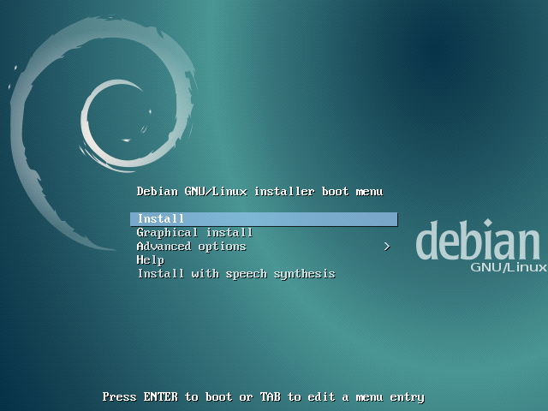

Seleccionamos la opción “Graphical install” para instalarlo de forma gráfica.
Luego nos pedirá seleccionar el idioma y el país, luego de cada selección presionamos continuar (“Continue”)

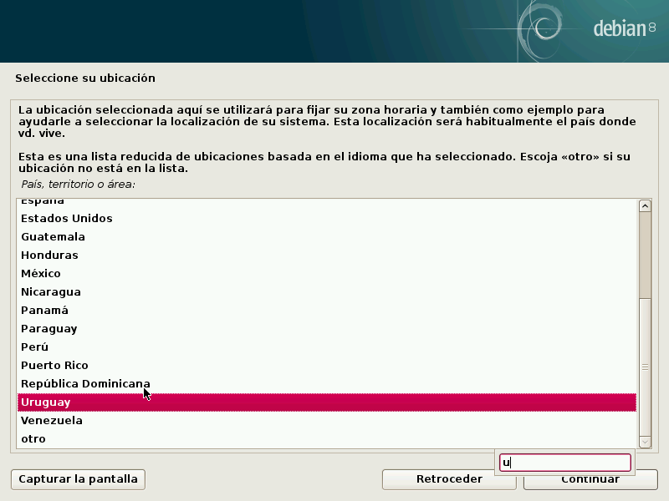
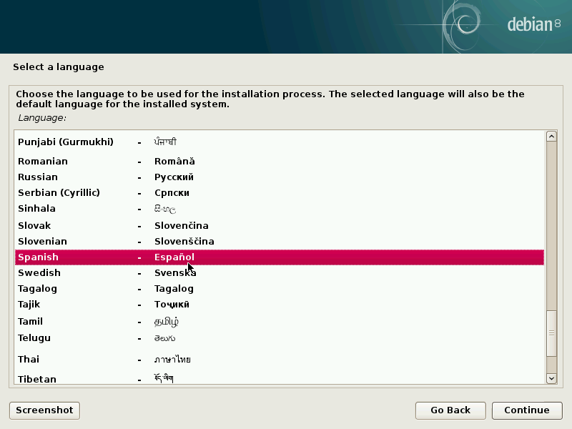

Seleccionamos el idioma del teclado y continuamos:
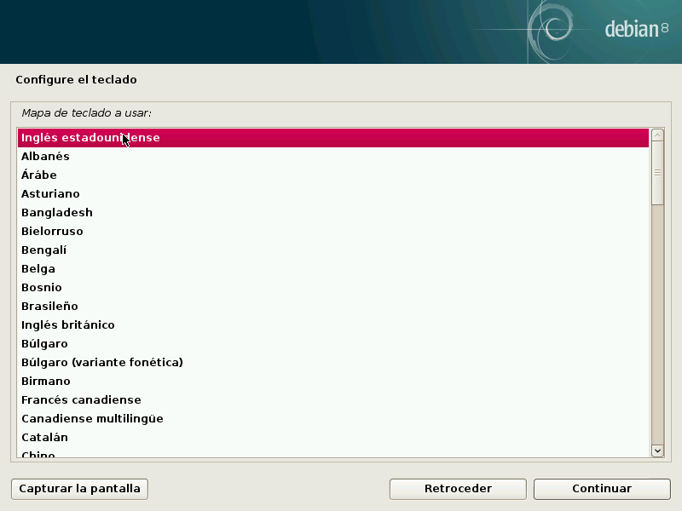
Luego esperamos mientras se configura la red (se recomienda conexión alámbrica/cableada para evitar inconvenientes)
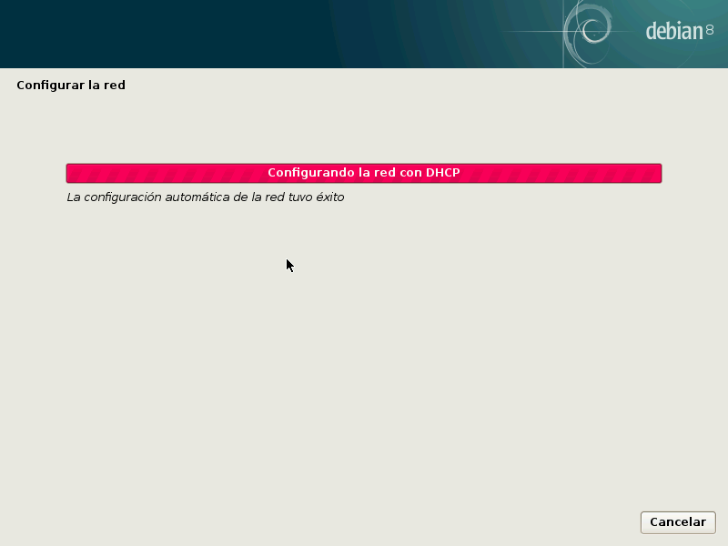

Ingresamos el nombre de nuestra máquina, en este caso como podemos observar será “ISUserver.local”. Dar click en continuar.
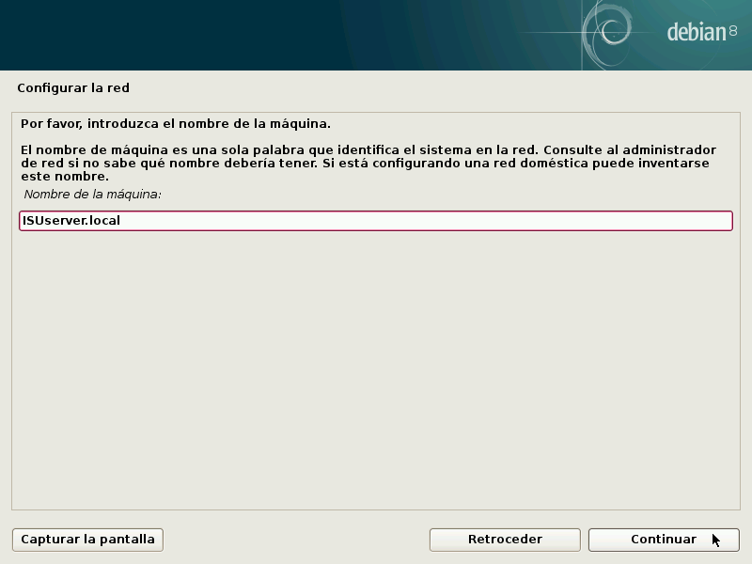

Ingresamos la contraseña de superusuario (root). Continuamos
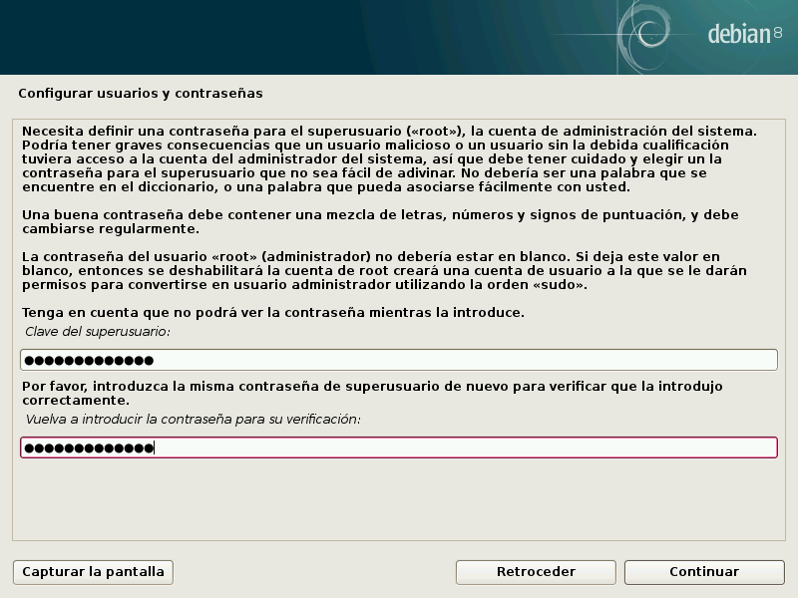
Luego ingresaremos el nombre completo para el usuario nuevo y tras continuar ingresaremos un nombre de usuario para la cuenta.

Sugerencia: “Su nombre, sin apellidos, ni espacios, es una elección razonable.”

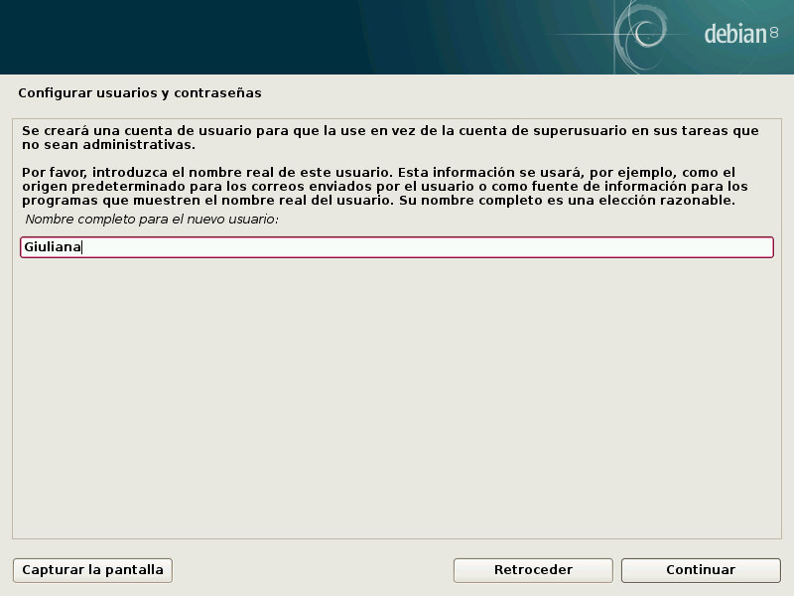
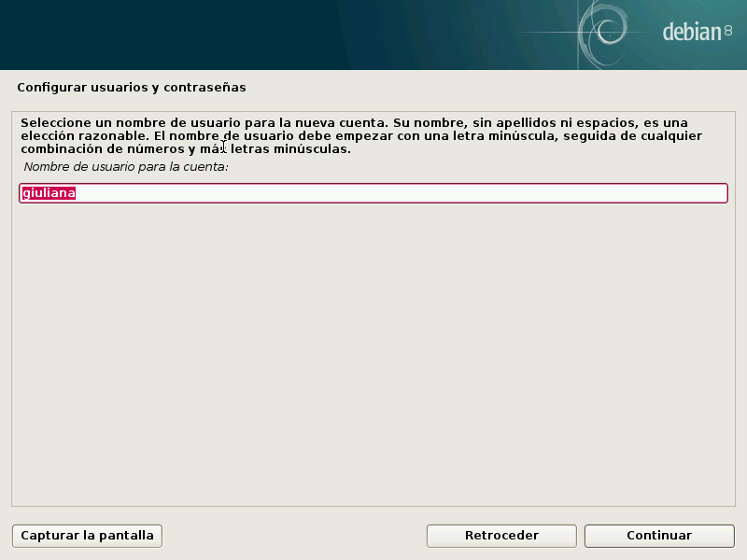

Ingresamos la contraseña del usuario creado y proseguimos, luego esperamos mientras se realizan algunas configuraciones.
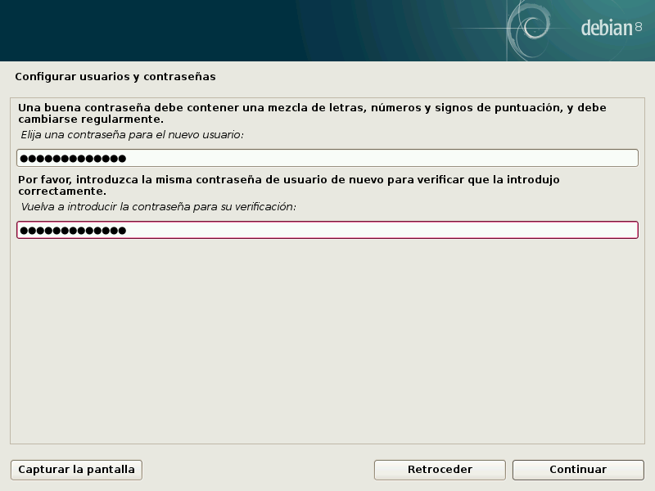
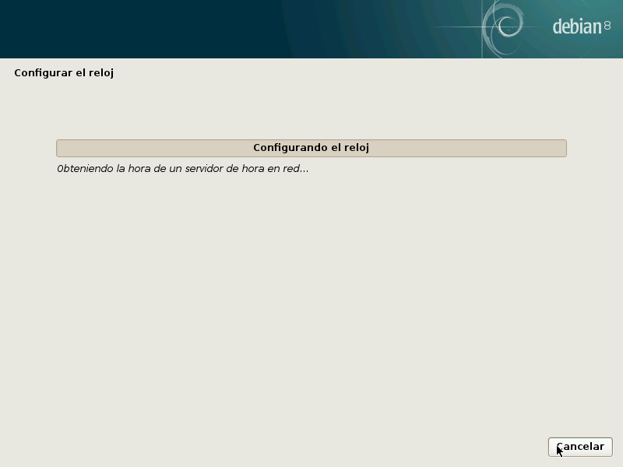

Comenzamos con las configuraciones del disco duro, para ello seleccionamos “Manual” y continuamos para poder seleccionar el disco duro y avanzar:
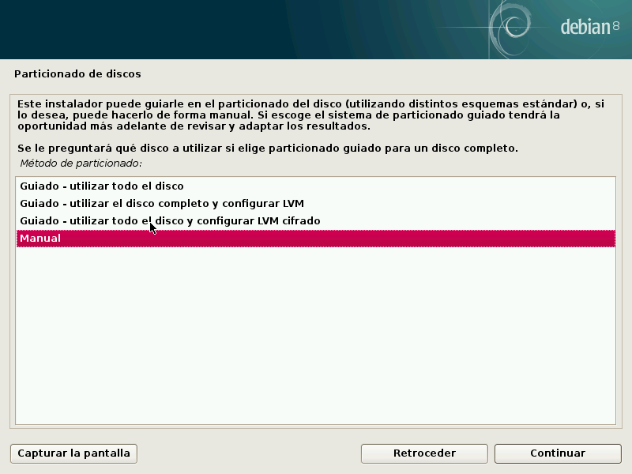
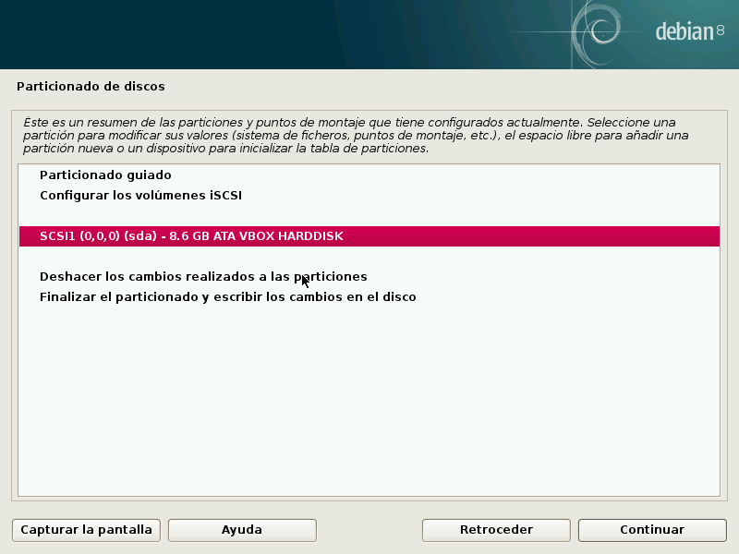
Seleccionamos “Si” en el menú de particionar el disco
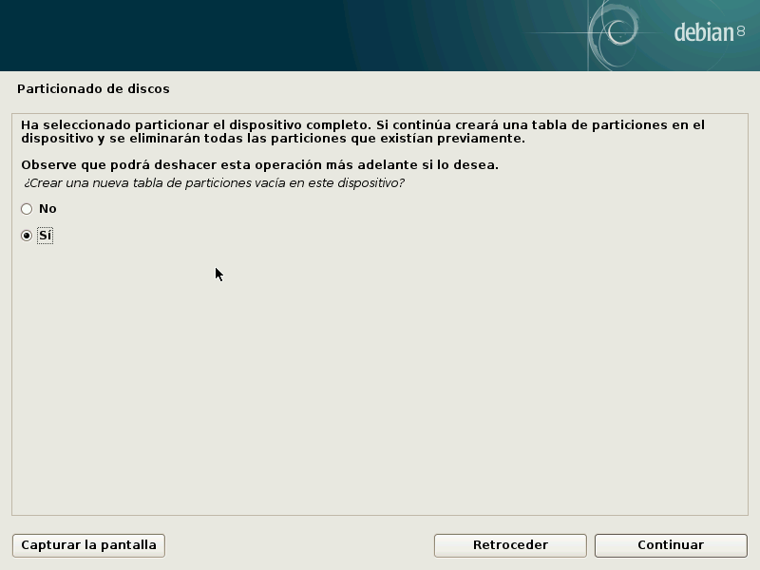

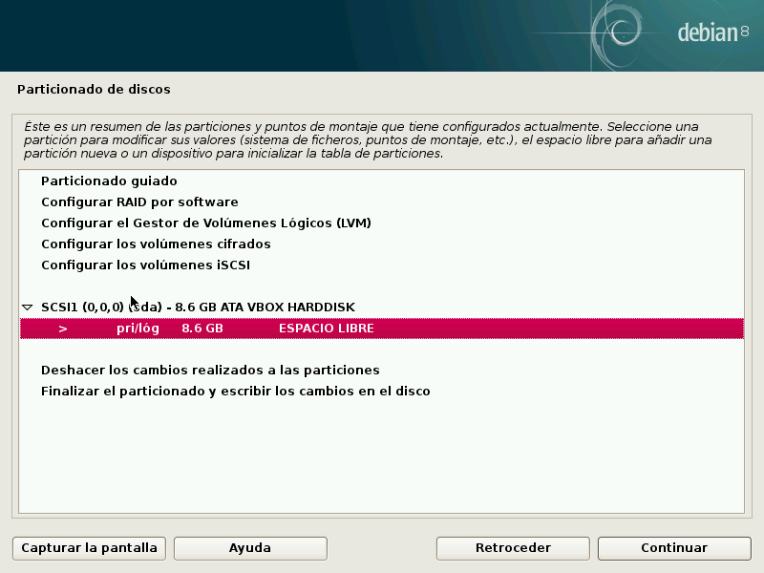
Elegimos la opción del espacio libre que será la que particionaremos, y continuaremos.

Crearemos una nueva partición y proseguiremos a elegir el tamaño de la misma y si es una partición lógica o primaria (seleccionaremos primaria).
También seleccionaremos donde deseamos que la nueva partición se cree, si al principio o al final del espacio disponible (escogeremos principio). Finalmente seleccionaremos que se ha terminado de definir la partición y repetimos los pasos de la partición anterior (elegimos espacio libre para crear la nueva partición).
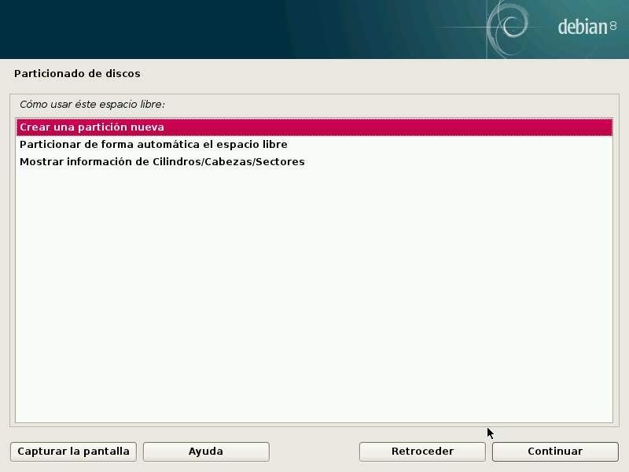

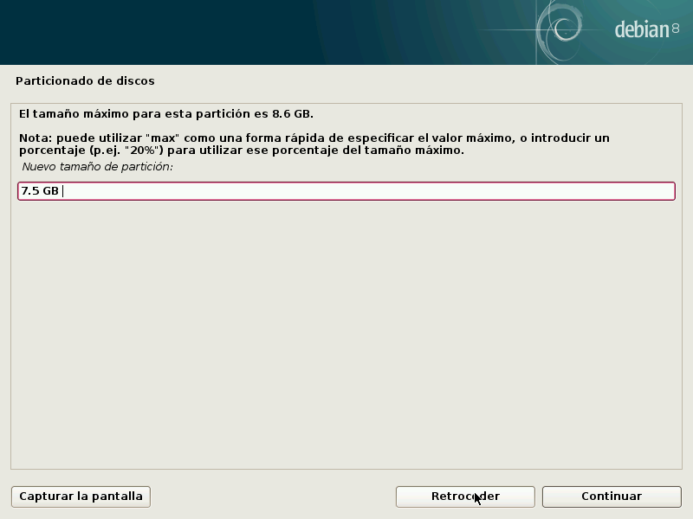
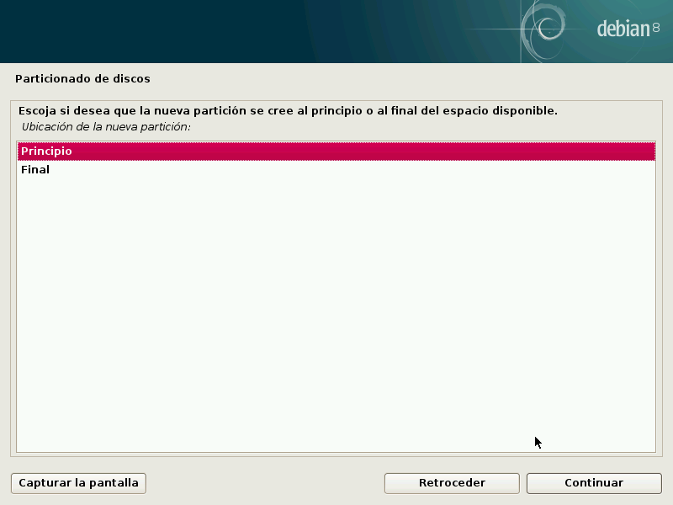

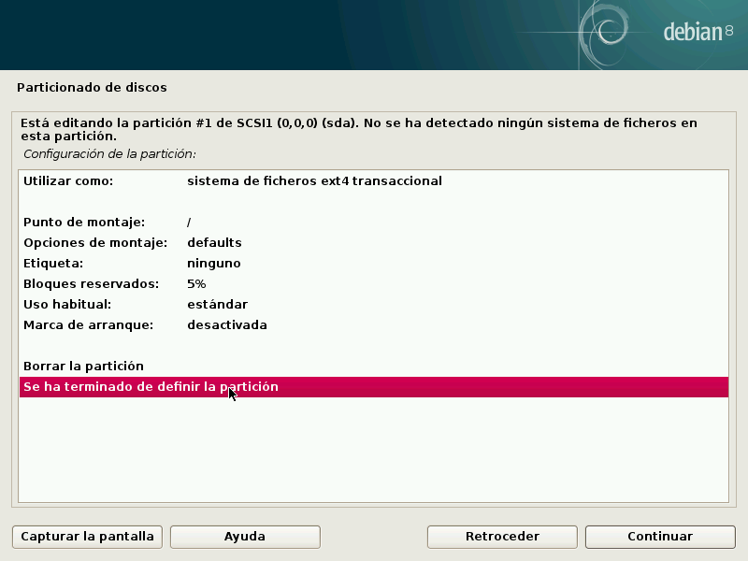
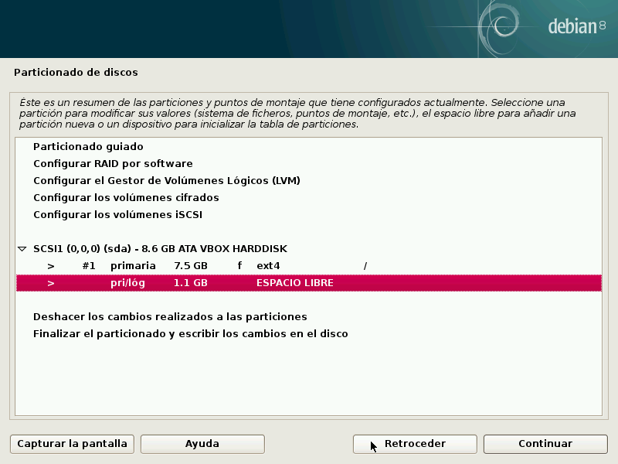

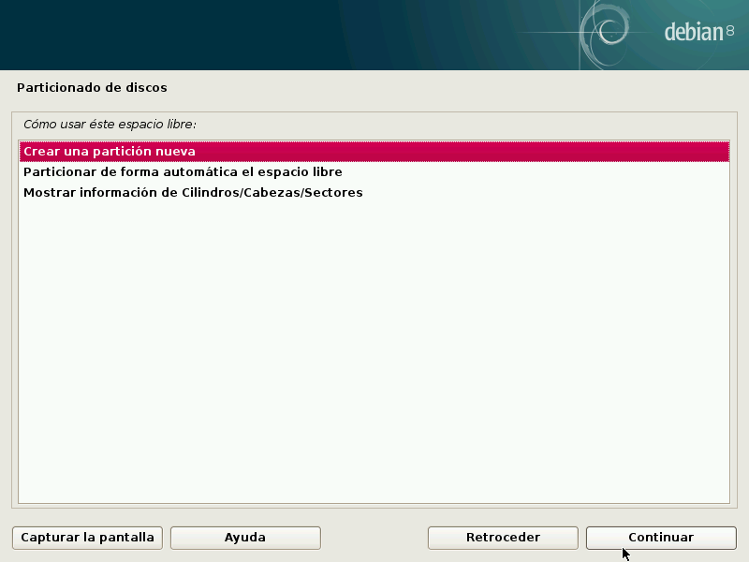

Elegimos crear una partición nueva, seleccionaremos el tamaño de ella, ahora seleccionaremos partición lógica en lugar de primaria y tras continuar podremos modificar la opción “Utilizar como: “ y seleccionaremos área de intercambio (swap) y terminamos la partición nueva

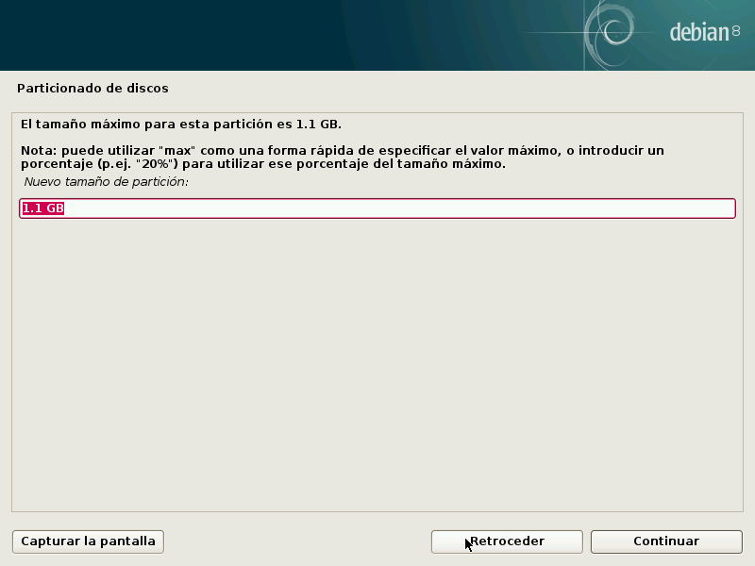
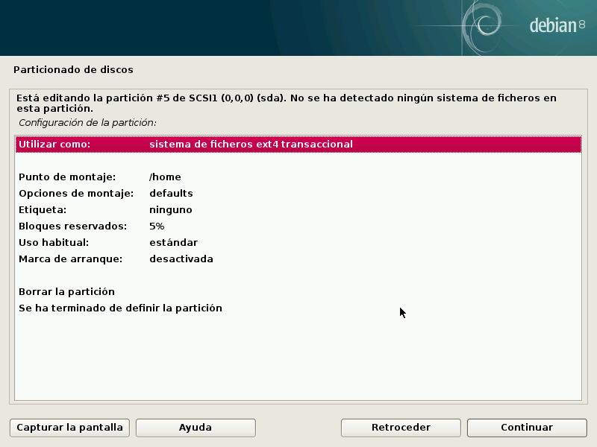

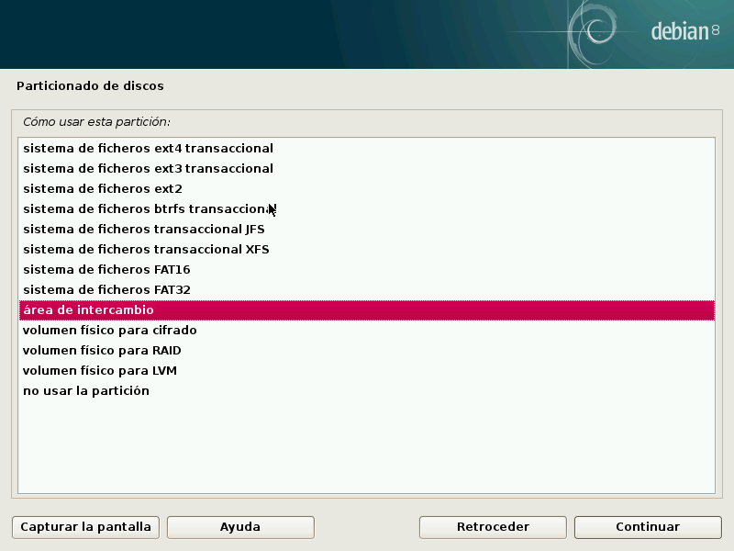
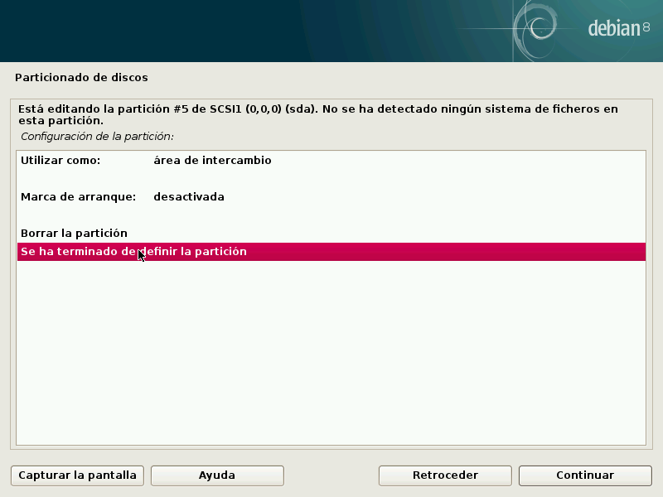

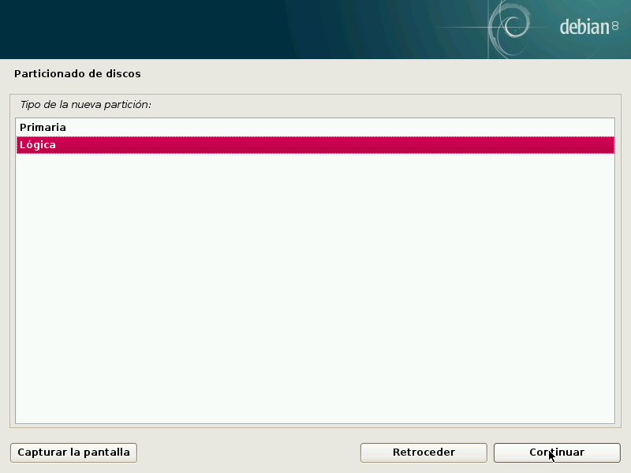
Finalizamos el proceso de particionado y accedemos a escribir los cambios del disco. Nos pide confirmar que deseamos guardar los cambios de los discos, seleccionamos “Si” para dar paso al formateo y esperamos mientras prepara las particiones, formatea el disco e instala el sistema base.

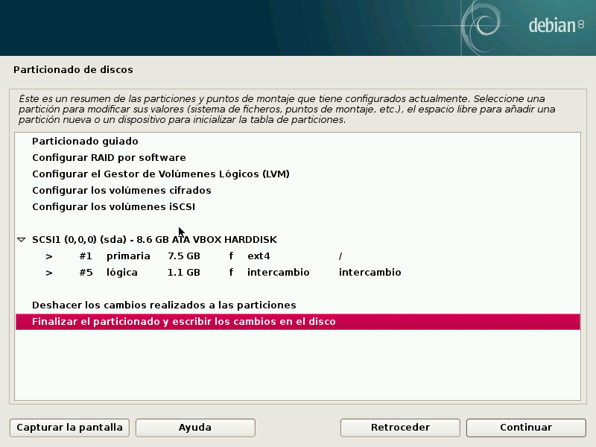
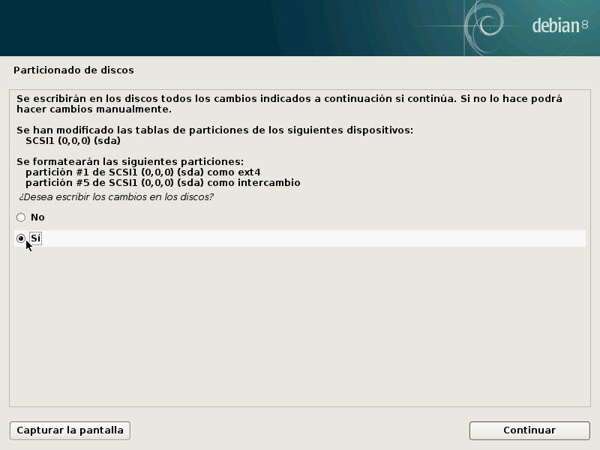

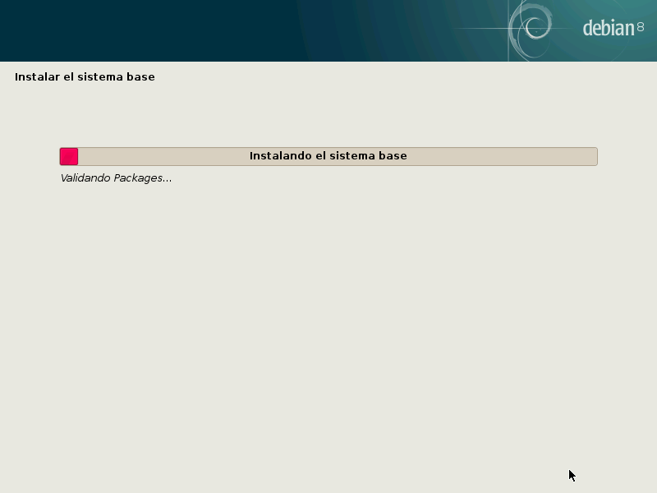

A continuación nos preguntara si deseamos analizar otro CD o DVD, en este caso seleccionaremos “No”, en el consiguiente menú nos pregunta si nos interesa utilizar una replica de red, volveremos a elegir la opción “No” y volveremos a esperar, se instalaran paquetes y programas.
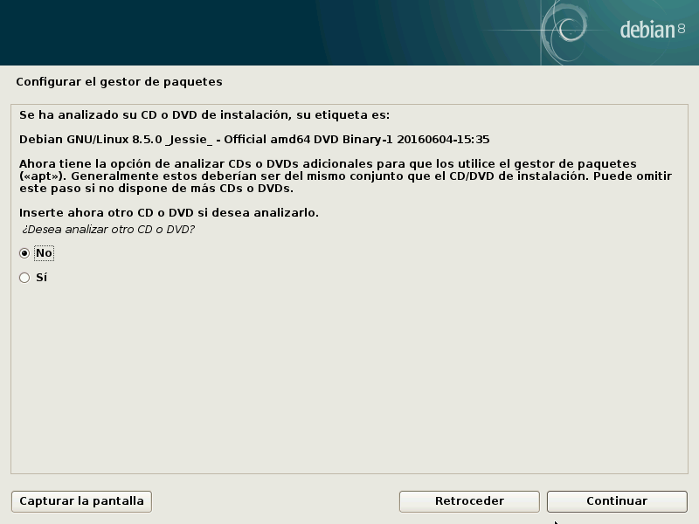

Preguntará sobre el interés de participar en una encuesta sobre el uso de paquetes, seleccionamos “No”, siguiente a eso nos aparecerán los programas a instalar y algunos ya vendrán seleccionados por defecto, seleccionaremos tres más: “GNOME”, “Web server” y “SSH server”.
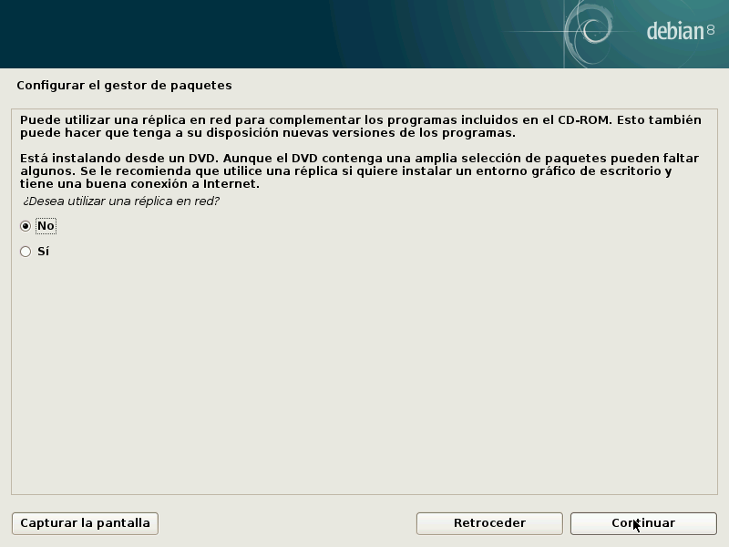

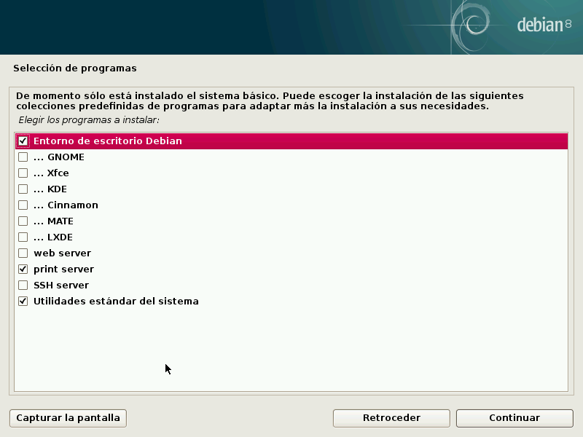

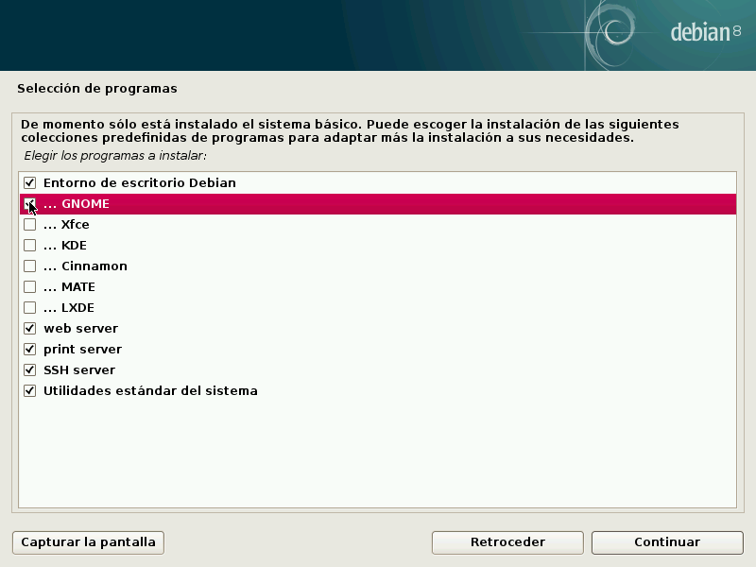

Esperamos mientras instala los programas seleccionados anteriormente, nos preguntará si deseamos instalar el cargador de arranques GRUB en el registro de arranque a lo cual responderemos que “Si”, luego seleccionamos el dispositivo donde instalaremos el cargador de arranque.

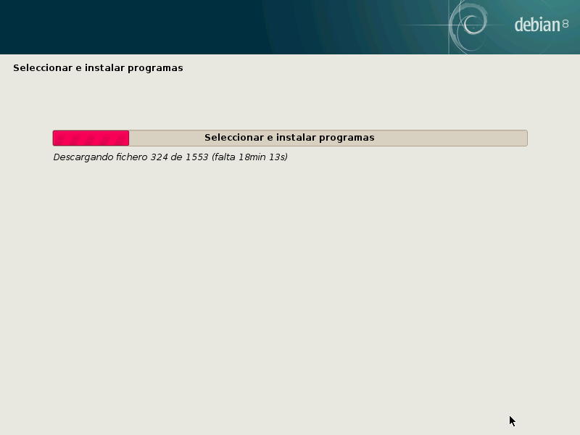
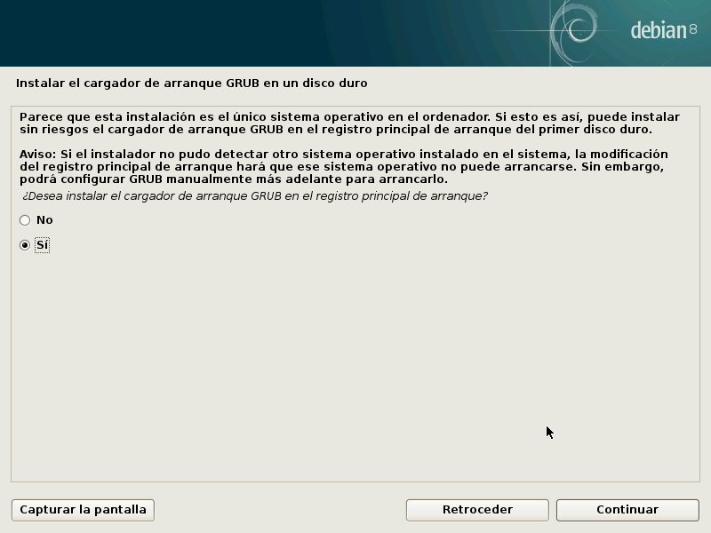

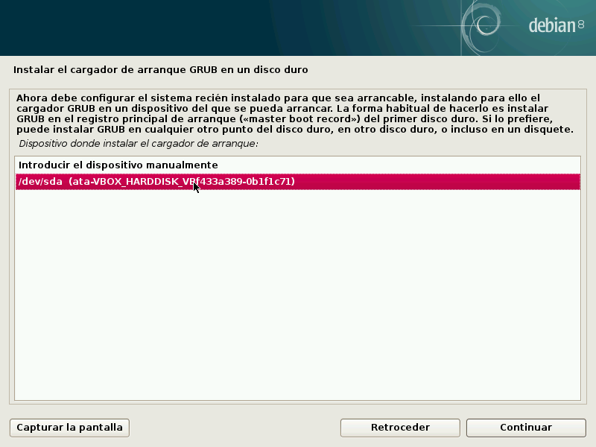

Nos indicara que la instalación ha finalizado, se reiniciara automáticamente y finalmente tendremos el Login en modo gráfico donde seleccionaremos nuestro usuario e ingresaremos la contraseña para iniciar sesión y estaremos logeados para comenzar a trabajar en el sistema.
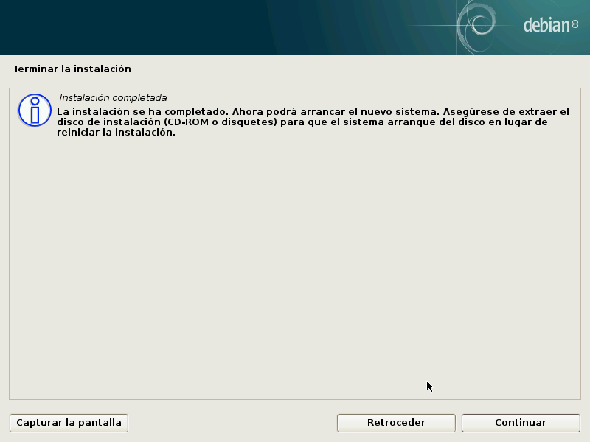

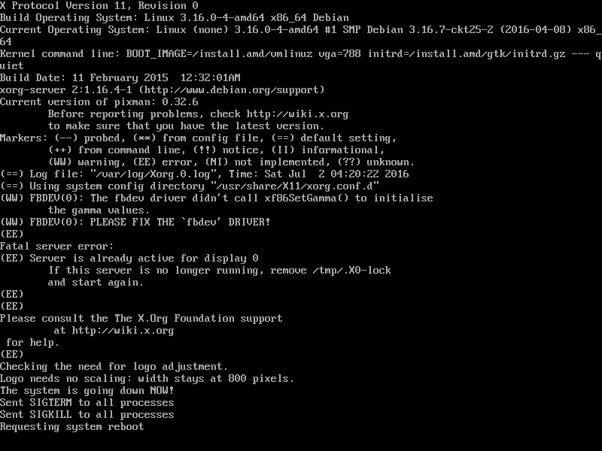
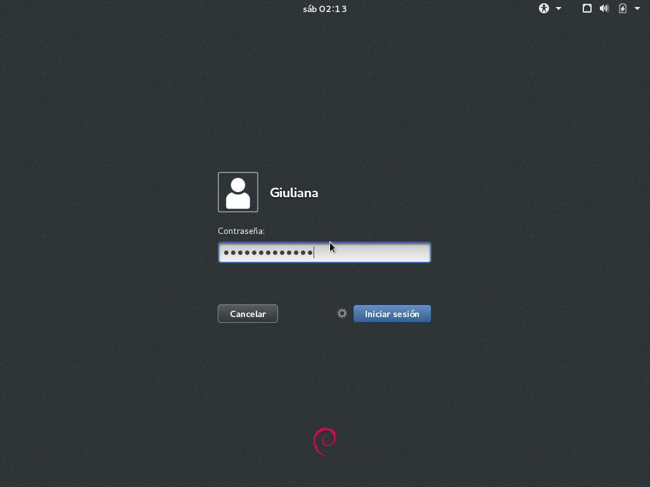

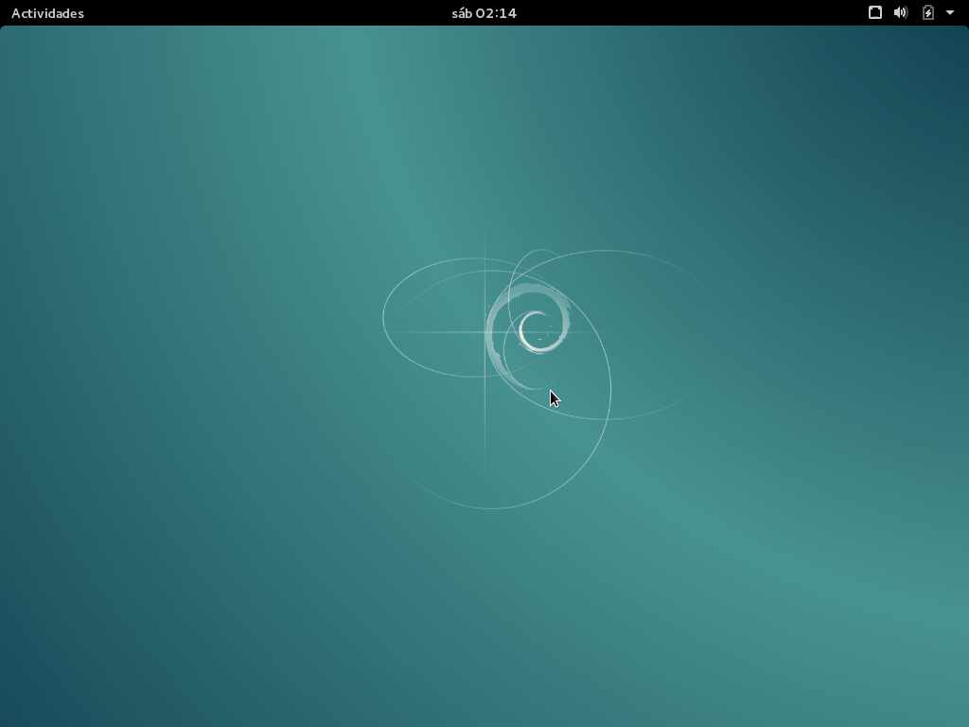

4. Shellescripts
4.1. Menu general
#!/bin/bash
tput setab 7
tput setaf 0
op=0
while [ $op -ne 3 ]
do
clear
tput cup 1 3 ; echo "I. S." ; tput cup 1 8; tput setaf 4 ; echo " U. insumos y soporte al usuario"; tput setaf 0
tput cup 3 3 ; echo "1) Usuario"
tput cup 4 3 ; echo "2) Animales"
tput cup 5 3 ; echo "3) Grupo"
tput cup 6 3 ; echo "4) Salir"
tput cup 8 3 ; echo "Opcion: "
tput cup 8 12; read op
case $op in
1) . . menuUsuario.sh ;;
2) . AnimaleMenu.sh ;;
3) . menuGrupo.sh ;;
4) ;;
*) tput cup 2 3; tput setaf 1; read -p "Dato no valido" aux ; tput setaf 0 ;;
esac
done
4.2. Animal
4.2.1 Menu
#!/bin/bash
tput setab 7
tput setaf 0
op=0
while [ $op -ne 3 ]
do
clear
tput cup 1 3 ; echo "I. S." ; tput cup 1 8; tput setaf 4 ; echo " U. insumos y soporte al usuario"; tput setaf 0
tput cup 3 3 ; echo "1) Ingresar"
tput cup 5 3 ; echo "3) Consultar"
tput cup 6 3 ; echo "4) Eliminar"
tput cup 7 3 ; echo "5) Salir"
tput cup 8 3 ; echo "Opcion: "
tput cup 8 12; read op
case $op in
1) . AnimalIngresar.sh ;;
3) . AnimalConsultar.sh ;;
4) . AnimalElminar.sh ;;
5) ;;
*) tput cup 2 3; tput setaf 1; read -p "Dato no valido" aux ; tput setaf 0 ;;
esac
done
4.2.2. Ingresar
#!/bin/bash
tput setab 7
tput setaf 0
op=0
DnNum=0
while [ $op -ne 3 ]
do
clear
tput cup 1 3 ; echo "I. S." ; tput cup 1 8; tput setaf 4 ; echo " U. insumos y soporte al usuario"; tput setaf 0
tput cup 3 3 ; echo "Numero: "
tput cup 4 3 ; echo "Sexo: "
tput cup 5 3 ; echo "Nacimiento: "
tput cup 6 3 ; echo "Lugar actual: "
tput cup 7 3 ; echo "Raza: "
tput cup 8 3 ; echo "Division: "
tput cup 9 3 ; echo "Num. Progenitor hembra"
tput cup 10 3 ; echo "Num. Progenitor macho"
while [DnNum -eq 0]
do
tput cup 3 11 ; read num
busqueda=$(grep "^$num:" BaseAnimal.txt)
if [ -z $busqueda ] #si no existe el usuario se peude crear
tput cup 4 9 ; read sexo
tput cup 5 15 ; read nac
tput cup 6 17 ; read lug
tput cup 7 9 ; read raza
tput cup 8 13 ; read div
tput cup 9 28 ; read numh
tput cup 10 27 ; read numm
echo "$num:$sexo:$nac:$lug:$raza:$div" >> BaseAnimal.txt
echo "$num:$numh:$numm" >> BaseAnimalG.txt
fi
then
done
done
4.2.3. Eliminar
#!/bin/bash
tput setab 7
tput setaf 0
op=0
while [ $op -ne 3 ]
do
clear
tput cup 1 3 ; echo "I. S." ; tput cup 1 8; tput setaf 4 ; echo " U. insumos y soporte al usuario"; tput setaf 0
tput cup 3 3 ; echo "Numero: "
tput cup 3 11 ; read num
sed '/$num/ d' BaseAnimal.txt > fichero2.txt
done
4.2.4. Consultar
#!/bin/bash
tput setab 7
tput setaf 0
op=0
while [ $op -ne 3 ]
do
clear
tput cup 1 3 ; echo "I. S." ; tput cup 1 8; tput setaf 4 ; echo " U. insumos y soporte al usuario"; tput setaf 0
tput cup 3 3 ; echo "Numero: "
tput cup 3 11 ; read num
grep "^$num:" BaseAnimal.txt
grep "^$num:" BaseAnimalG.txt
done
4.3. Usuario
4.3.1. Menu
#!/bin/bash
op=0
while [ $op -ne 5 ]
do
clear
tput cup 1 3; echo "I. S."; tput cup 1 8; tput setaf 4 ; echo " U. insumos y soporte al usuario"
tput cup 3 3; tput setaf 0 ; echo "1) Dar de alta a un usuario"
tput cup 4 3; echo "2) Dar de baja a un usuario"
tput cup 5 3; echo "3) Modificar un usuario"
tput cup 6 3; echo "4) Consulta de usuario"
tput cup 7 3; echo "5) Atras"
tput cup 8 3; read -p "Opcion: " op
case $op in
1) . altaUsuario.sh;;
2) . bajaUsuario.sh;;
3) . modificarUsuario.sh;;
4) . consultarUsuario.sh;;
5);;
*) tput cup 2 3; tput setaf 1; read -p "Dato no valido" aux ; tput setaf 0
op=0
;;
esac
done
4.3.2. Ingresar
#!/bin/bash
clear
tput cup 3 3; echo "Login :"
tput cup 4 3; echo "Cedula de identidad :"
tput cup 5 3; echo "Directorio de trabajo :"
tput cup 6 3; echo "Grupo al que pertencera :"
DnLogg=0
DnCI=0
echo "$DnCI" > aux2.txt
DnGroupp=0
while [ $DnLogg -eq 0 ]
do
tput cup 3 12; read Logg
busqueda=$(grep "^$Logg:" /etc/passwd)
if [ -z $busqueda ] #si no existe el usuario se peude crear
then
DnLogg=1
while [ $DnCI -eq 0 ]
do
tput cup 4 25; read CI
echo $CI > aux.txt
. verificar.sh # Chequea que el numero verificador sea el correcto, al igual que a cantidad de digitos
DnCI=$(cat aux2.txt)
done
tput cup 5 27; read Homee
while [ $DnGroupp -eq 0 ]
do
tput cup 6 29; read Groupp
busqueda=$(cut -d: -f1 /etc/group | grep "$Groupp")
if [ -z $busqueda ]
then
busqueda=$(cut -d: -f3 /etc/group | grep "$Groupp")
if [ -z $busqueda ]
then
tput cup 2 3; tput setaf 1; read -p "Ingrese un grupo valido" aux; tput setaf 0
else
DnGroupp=1
fi
else
DnGroupp=1
fi
done
if sudo useradd -d $Homee -mk /etc/skel -g $Groupp -c "$CI" -s /bin/shell $Logg
then
tput cup 2 3; tput setaf 2 ; read -p "Usuario creado" ; tput setaf 0
sudo passwd $Logg
else
tput cup 2 3; tput setaf 1; read -p "Error" aux; tput setaf 0
fi
else
tput cup 2 3; tput setaf 1; read -p "El usuario ya existe" aux; tput setaf 0
fi
done
rm aux.txt
rm aux2.txt
4.3.2.1 Verificar
#!/bin/bash
come=$(cat aux.txt)
ci[0]=0
ci[1]=0
ci[2]=0
ci[3]=0
ci[4]=0
ci[5]=0
ci[6]=0
ci[7]=0
cont=7
while [ $cont -ge 0 ]
do
let cii=$come/10
let aux=$cii*10
let ci[$cont]=$come-$aux
come=$cii
let cont=$cont-1
done
if [ ${ci[0]} -eq 0 ]
then
tput cup 2 3; tput setaf 1 ; read -p "Faltan digitos" ; tput setaf 0
else
if [ $come -gt 0 ]
then
tput cup 2 3 ; tput setaf 1 ; read -p "Sobran digitos" ; tput setaf 0
else
acum=0
i=0
while [ $i -lt 8 ]
do
case $i in
0) let ci[$i]=${ci[$i]}*2
let acum=$acum+${ci[$i]}
;;
1) let ci[$i]=${ci[$i]}*9
let acum=$acum+${ci[$i]}
;;
2) let ci[$i]=${ci[$i]}*8
let acum=$acum+${ci[$i]}
;;
3) let ci[$i]=${ci[$i]}*7
let acum=$acum+${ci[$i]}
;;
4) let ci[$i]=${ci[$i]}*6
let acum=$acum+${ci[$i]}
;;
5) let ci[$i]=${ci[$i]}*3
let acum=$acum+${ci[$i]}
;;
6) let ci[$i]=${ci[$i]}*4
let acum=$acum+${ci[$i]}
;;
7) sig0=$acum
acum2=$acum
let sig0=$acum/10
let sig0=$sig0*10
let sig0=$acum-$sig0
while [ $sig0 -ne 0 ]
do
let acum2=$acum2+1
let sig0=$acum2/10
let sig0=$sig0*10
let sig0=$acum2-$sig0
done
let veri=$acum-$acum2
let veri=-$veri
come=$(cat aux.txt)
if [ ${ci[7]} -ne $veri ]
then
tput cup 2 3; tput setaf 1; read -p "CI invalida"; tput setaf 0
else
chequeo=$(grep $come /etc/passwd)
if [ -z $chequeo ] #si no existe el usuario con esa ci se peude crear
then
echo "1" > aux2.txt
tput cup 2 3; tput setaf 2 ; read -p "La CI fue verificada"; tput setaf 0
else
tput cup 2 3; tput setaf 1; read -p "CI ya registrada"; tput setaf 0
fi
fi
;;
esac
let i=$i+1
done
fi
fi
4.3.3. Eliminar
#!/bin/bash
DnBaja=0
while [ $DnBaja -eq 0 ]
do
clear
tput cup 3 3; echo "Ingrese el Login o cedula"
tput cup 4 3; read CI
busqueda=$(cut -d: -f5 /etc/passwd | grep -n "$CI" | cut -d: -f1)
if [ -z $busqueda ]
then
busqueda=$(cut -d: -f1 /etc/passwd | grep -n "$CI" | cut -d: -f1)
if [ -z $busqueda ]
then
tput cup 2 3; tput setaf 1; read -p "Ingrese un grupo valido" aux; tput setaf 0
else
Logg=$CI
DnBaja=1
fi
else
Logg=$(head -$busqueda /etc/passwd | tail -1 | cut -d: -f1 )
DnBaja=1
fi
if [ $DnBaja -eq 1 ]
then
clear
tput cup 3 3; echo "1) Baja logica de $Logg"
tput cup 4 3; echo "2) Eliminacion de $Logg"
tput cup 5 3; read op
case $op in
1) if sudo usermod -L $Logg
then
tput cup 2 3; tput setaf 2; read -p "Se dio baja logica a $Logg" aux ; tput setaf 0
else
tput cup 2 3; tput setaf 1; read -p "Error" aux; tput setaf 0
fi
;;
2) clear
tput cup 3 3; read -p "Eliminar el home (S/N) " eliminar
case $eliminar in
"S"|"s") if sudo userdel -r $Logg
then
tput cup 2 3; tput setaf 2; read -p "Se eliminó el home y registro de $Logg" aux ; tput setaf 0
else
tput cup 2 3; tput setaf 1; read -p "Error" aux; tput setaf 0
fi
;;
"N"|"n") if sudo userdel $Logg
then
tput cup 2 3; tput setaf 2; read -p "Se eliminó el registro de $Logg" aux ; tput setaf 0
else
tput cup 2 3; tput setaf 1; read -p "Error" aux; tput setaf 0
fi
;;
*) tput cup 2 3; tput setaf 1; read -p "Ingrese un dato valido" aux; tput setaf 0
;;
esac
;;
*) tput cup 2 3; tput setaf 1; read -p "Ingrese un dato valido" aux; tput setaf 0
;;
esac
fi
done
4.3.4. Modificar
#!/bin/bash
DnMenu=0
while [ $DnMenu -eq 0 ]
do
clear
tput cup 3 3; read -p "Ingrese la ci del usuario a modificar " ci
busqueda=$(cut -d: -f5 /etc/passwd | grep -n "$ci"|cut -d: -f1)
if [ -z $busqueda ]
then
tput cup 2 3; read -p "No existe usuario con esa CI " aux
else
clear
Logg=$(head -$busqueda /etc/passwd | tail -1 | cut -d: -f1 )
tput cup 3 3; echo "Dato a modificar de $Logg, ci: $ci"
tput cup 4 3; echo "1) Directorio de trabajo "
tput cup 5 3; echo "2) Cedula"
tput cup 6 3; echo "3) Grupo"
tput cup 7 3; echo "4) Log"
tput cup 8 3; echo "5) Levantar baja logica"
tput cup 9 3; echo "6) Atras"
tput cup 10 3; read op
DnMod=0
while [ $DnMod -eq 0 ]
do
clear
case $op in
1) HomeeO=$(head -$busqueda /etc/passwd | tail -1 | cut -d: -f6 )
tput cup 3 3; read -p "Ingrese el nombre del nuevo directorio de trabajo" Homee
if sudo usermod -m -d $Homee $Logg
then
tput cup 2 3; tput setaf 2; read -p "El directorio de trabajo de $Logg fue cambiado a $Homee " aux; tput setaf 0
DnMod=1
else
tput cup 2 3; tput setaf 1; read -p "Error" aux ;tput setaf 0
fi
;;
2) DnCI=0
while [ $DnCI -eq 0 ]
do
tput cup 3 3; read -p "Ingrese CI nueva " CI
echo $CI > aux.txt
. verificar.sh
DnCI=$(cat aux2.txt)
done
if sudo usermod -c $CI $Logg
then
tput cup 2 3; tput setaf 2; read -p "CI de $Logg fue cambiado a $CI" aux; tput setaf 0
DnMod=1
else
tput cup 2 3; tput setaf 1; read -p "Error" aux;tput setaf 0
fi
;;
3) tput cup 3 3; read -p "Ingrese el grupo nuevo " Groupp
busqueda=$(cut -d: -f1 /etc/group | grep "$Groupp")
if [ -z $busqueda ]
then
busqueda=$(cut -d: -f3 /etc/group | grep "$Groupp")
if [ -z $busqueda ]
then
DnMod=1
else
tput cup 2 3; tput setaf 1; read -p "Ingrese un grupo valido" aux; tput setaf 0
fi
else
if sudo usermod -g $Groupp $Logg
then
DnMod=1
else
tput cup 2 3; tput setaf 1; read -p "Error" aux ;tput setaf 0
fi
fi
if [ $DnMod -eq 1 ]
then
tput cup 2 3; tput setaf 2; read -p "Grupo de $Logg fue cambiado a $Groupp" aux; tput setaf 0
fi
;;
4) tput cup 3 3; read -p "Ingrese el login nuevo " LoggN
busqueda=$(grep "^$LoggN" /etc/passwd)
if [ -z $busqueda ]
then
if sudo usermod -l $LoggN $Logg
then
tput cup 2 3; tput setaf 2; read -p "el login de $Logg fue cambiado a $LoggN" aux; tput setaf 0
DnMod=1
else
tput cup 2 3; tput setaf 1; read -p "Error" aux;tput setaf 0
fi
else
tput cup 2 3; tput setaf 1; read -p "Ingrese un login valido" aux; tput setaf 0
fi
;;
5) if sudo usermod -U $Logg
then
tput cup 2 3; tput setaf 2; read -p "Se levanto la baja logica de $Logg" aux; tput setaf 0
DnMod=1
else
tput cup 2 3; tput setaf 1; read -p "Error" aux;tput setaf 0
fi
;;
6) DnMod=1
;;
*) tput cup 2 3; tput setaf 1; read -p "Ingrese un dato valido" aux; tput setaf 0
;;
esac
if [ $DnMod -eq 1 ]
then
DnMenu=1
fi
done
fi
done
4.3.5. Consultar
#!/bin/bash
DnLogg=0
while [ $DnLogg -eq 0 ]
do
clear
tput cup 3 3; read -p "Ingrese el usuario a buscar: " Logg
busqueda=$(grep "^$Logg:" /etc/passwd)
if [ -z $busqueda ]
then
tput cup 2 3; tput setaf 1;read -p "No existe el usuario" aux; tput setaf 0
else
tput cup 2 3; tput setaf 2; echo "El usuario $Logg fue encontrado"; tput setaf 0
aux1=$(echo $busqueda | cut -d: -f1)
tput cup 6 3; echo "Usuario : $aux1"
aux1=$(echo $busqueda | cut -d: -f3)
tput cup 7 3; echo "UID : $aux1"
aux1=$(echo $busqueda | cut -d: -f4)
tput cup 8 3; echo "GID : $aux1"
aux1=$(echo $busqueda | cut -d: -f6)
tput cup 9 3; echo "Home: $aux1"
tput cup 11 3; read -p "Presiona ENTER para continuar..." aux
DnLogg=1
fi
done
4.4. Grupo
4.4.1. Menu
#!/bin/bash
op=0
while [ $op -ne 5 ]
do
clear
tput cup 1 3; echo "I. S."; tput cup 1 8; tput setaf 4 ; echo " U. insumos y soporte al usuario"
tput cup 3 3; tput setaf 0 ; echo "1) Dar de alta un grupo"
tput cup 4 3; echo "2) Dar de baja un grupo"
tput cup 5 3; echo "3) Modificar un grupo"
tput cup 6 3; echo "4) Consulta un grupo"
tput cup 7 3; echo "5) Atras"
tput cup 8 3; read -p "Opcion: " op
case $op in
1) . altaGrupo.sh;;
2) . bajaGrupo.sh;;
3) . modificarGrupo.sh;;
4) . consultarGrupo.sh;;
5) ;;
*) tput cup 2 3; tput setaf 1; read -p "Dato no valido" aux ; tput setaf 0
op=0
;;
esac
done
4.4.2. Ingresar
#!/bin/bash
DnAlta=0
while [ $DnAlta -eq 0 ]
do
clear
tput cup 3 3; echo "Nombre del grupo :"
tput cup 4 3; echo "GID :"
DnGroupp=0
DnGid=0
while [ $DnGroupp -eq 0 ]
do
tput cup 3 22; read Groupp
busqueda=$(cut -d: -f1 /etc/group |grep "$Groupp")
if [ -z $busqueda ]
then
DnGroupp=1
while [ $DnGid -eq 0 ]
do
tput cup 4 9; read GIDD
busqueda=$(cut -d: -f3 /etc/group | grep "$GIDD")
if [ -z $busqueda ]
then
DnGid=1
if sudo groupadd -g $GIDD $Groupp
then
tput cup 2 3; tput setaf 2; read -p "Grupo $Groupp, creado" aux; tput setaf 0
DnAlta=1
else
tput cup 2 3; tput setaf 1; read -p "Error"; tput setaf 0
fi
else
tput cup 2 3; tput setaf 1; read -p "Ingrese un GID valido" aux; tput setaf 0
fi
done
else
tput cup 2 3; tput setaf 1; read -p "Ingrese un grupo valido" aux; tput setaf 0
fi
done
done
4.4.3. Eliminar
#!/bin/bash
DnGroupp=0
while [ $DnGroupp -eq 0 ]
do
clear
tput cup 3 3; echo "Grupo o GID a dar de baja"
tput cup 4 3; read GIDD
busqueda=$(cut -d: -f1 /etc/group |grep "$GIDD")
if [ -z $busqueda ]
then
busqueda=$(cut -d: -f3 /etc/group | grep -n "$GIDD" | cut -d: -f1)
if [ -z $busqueda ]
then
tput cup 2 3; tput setaf 1; read -p "Ingrese un grupo valido" aux; tput setaf 0
else
Groupp=$(head -$busqueda /etc/group | tail -1 | cut -d: -f1 )
DnGroupp=1
fi
else
Groupp=$GIDD
DnGroupp=1
fi
if [ $DnGroupp -eq 1 ]
then
if sudo groupdel $Groupp
then
tput cup 2 3; tput setaf 2; read -p "Grupo $Groupp, eliminado" aux; tput setaf 0
DnGroupp=1
else
tput cup 2 3; tput setaf 1; read -p "Error" aux; tput setaf
fi
fi
done
4.4.4. Modificar
#!/bin/bash
DnGroupp=0
DnMod=0
while [ $DnGroupp -eq 0 ]
do
clear
tput cup 3 3; echo "Grupo o GID a modificar"
tput cup 4 3; read GIDD
busqueda=$(cut -d: -f1 /etc/group |grep -n "$GIDD" | cut -d: -f1 )
if [ -z $busqueda ]
then
busqueda=$(cut -d: -f3 /etc/group | grep -n "$GIDD" | cut -d: -f1)
if [ -z $busqueda ]
then
tput cup 2 3; tput setaf 1; read -p "Ingrese un grupo valido" aux; tput setaf 0
else
Groupp=$(head -$busqueda /etc/group | tail -1 | cut -d: -f1 )
DnGroupp=1
fi
else
Groupp=$GIDD
DnGroupp=1
fi
if [ $DnGroupp -eq 1 ]
then
while [ $DnMod -eq 0 ]
do
clear
tput cup 3 3; echo "Dato a morificar "
tput cup 4 3; echo "1) Nombre del grupo"
tput cup 5 3; echo "2) GID"
tput cup 6 3; read op
clear
case $op in
1)
tput cup 4 3; read -p "Ingrese nuevo nombre " GroupN
busqueda=$(cut -d: -f1 /etc/group |grep "$GroupN")
if [ -z $busqueda ]
then
if sudo groupmod -n $GroupN $Groupp
then
tput cup 2 3; tput setaf 2; read -p "El grupo $grupo fue modificado por el nombre $GroupN" aux ; tput setaf 0
DnMod=1
else
tput cup 2 3; tput setaf 1; read -p "Error" aux; tput setaf 0
fi
else
tput cup 2 3; tput setaf 1; read -p "Ese nombre ya esta usado" aux; tput setaf 0
fi
;;
2)
tput cup 4 3; read -p "Ingrese nuevo GID " GIDN
busqueda=$(cut -d: -f3 /etc/group |grep "$GIDN")
if [ -z $busqueda ]
then
if sudo groupmod -g $GIDN $Groupp
then
tput cup 2 3; tput setaf 2; read -p "El GID de $Groupp fue modificado a $GIDN" aux ; tput setaf 0
DnMod=1
else
tput cup 2 3; tput setaf 1; read -p "Error" aux; tput setaf 0
fi
else
tput cup 2 3; tput setaf 1; read -p "Ese GID ya esta usado" aux; tput setaf 0
fi
;;
3);;
*) tput cup 2 3; tput setaf 1; read -p "Ingrese un dato valido" aux; tput setaf 0
esac
done
fi
done
4.4.5. Consultar
#!/bin/bash
DnGroupp=0
while [ $DnGroupp -eq 0 ]
do
clear
tput cup 3 3; echo "Grupo o GID a consultar"
tput cup 4 3; read GIDD
busqueda=$(cut -d: -f1 /etc/group |grep -n "$GIDD" | cut -d: -f1 )
if [ -z $busqueda ]
then
busqueda=$(cut -d: -f3 /etc/group | grep -n "$GIDD" | cut -d: -f1)
if [ -z $busqueda ]
then
tput cup 2 3; tput setaf 1; read -p "Ingrese un grupo valido" aux; tput setaf 0
else
DnGroupp=1
fi
else
Groupp=$GIDD
DnGroupp=1
fi
if [ $DnGroupp -eq 1 ]
then
busqueda=$(head -$busqueda /etc/group | tail -1 )
tput cup 2 3; tput setaf 2 ; echo "El grupo $Groupp fue encontrado" ; tput setaf 0
corte=$(echo $busqueda | cut -d: -f1)
tput cup 6 3; echo "Grupo: $corte"
corte=$(echo $busqueda | cut -d: -f3)
tput cup 7 3; echo "GID: $corte"
corte=$(echo $busqueda | cut -d: -f4)
tput cup 8 3; echo "Integrantes: $corte"
tput cup 9 3; read -p "" aux
fi
done

4.5. Respaldo
#!/bin/bash
aux=$(date %D %H)
dbexport isu /Coware/aux/
# crontab -l, crontab -e

